

SRV Management System

End User Documentation v00.0011

By Team NAG

Introduction to SRV 4

Installation instructions 5

Where to locate the program 5

How to install SRV Management System using the Installation File 6

How to use SRV Management System 10

How to login as a Student 10

How to view the dashboard 11

How to access SRV 12

How to filter by courses 13

How to export the table to a PDF file 14

How to login as a Lecturer 15

How to view the dashboard 16

How to access SRV 17

How to filter by courses 18

How to login as an Administrator 19

How to view the dashboard 20

How to add an Administrator 21

How to Update an Administrator 23

How to delete an Administrator 24

How to add a Lecturer 26

How to Update a Lecturer 28

How to delete a Lecturer 29

How to add a Student 30

How to Update a Student 32

How to delete a Student 33

Troubleshooting & FAQ 34

Common problems 34

Contact details 35

About us 35

Acknowledgements 36

Notes 37

This documentation is intended for staff at ITWorks who are new to using SRV Management System. SRV Management System is owned by Team NAG and is distributed to the public as freeware.

This document is written in accordance to the ISO guidelines for software related user documentation.

Introduction to SRV

SRV will allow you to centralize your channel of communication with Students, Lecturers and Adminstration staff.

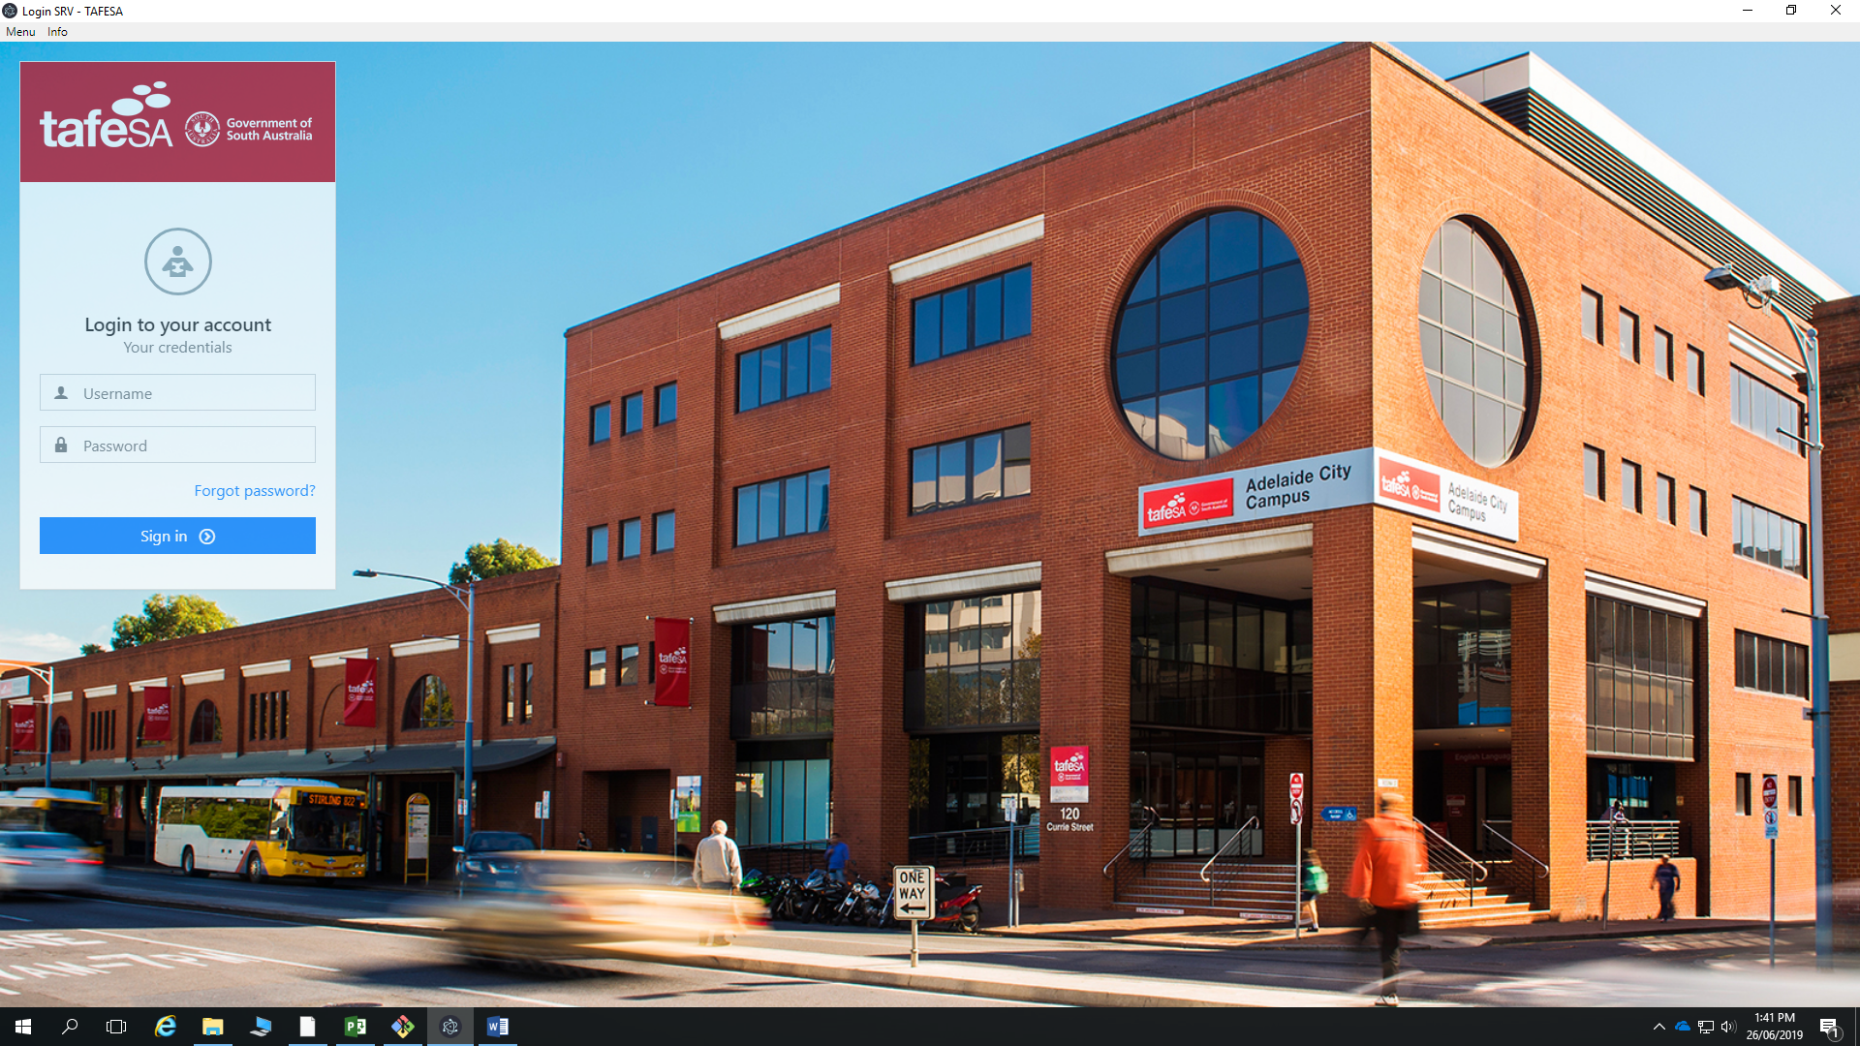

Figure 1: SRV Management System when first opened

SRV Management System will require:

* Microsoft Windows 2000 or greater, Linux or MAC
* CPU: 400 MHz or greater
* RAM: 512 MB or greater
* 500 MB hard drive space available

Installation instructions

Where to locate the program

SRV Management System can be found on their website at:

https://github.com/thinn5/5WORK2019

Just clone de repository and execute the file.

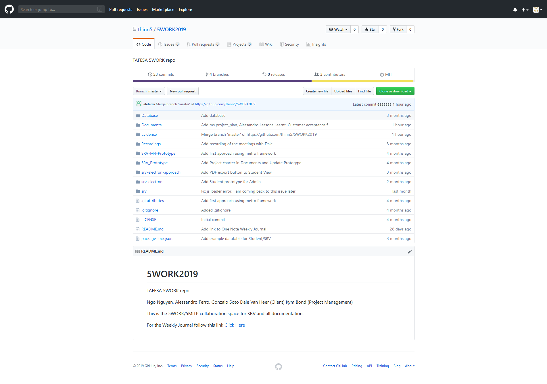

Figure 2: The download page for SRV Management System

How to install SRV Management System using the Installation File

To install SRV Management System you will need to clone the repository https://github.com/thinn5/5WORK2019

1. Double click on the installation file to start the installation wizard.

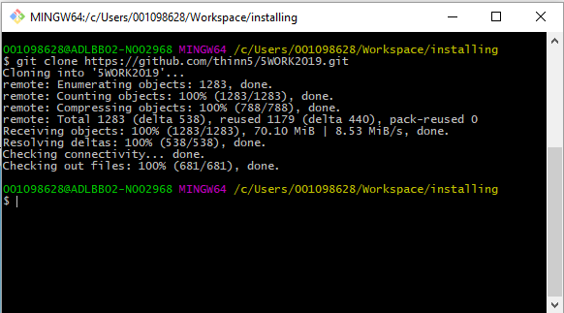

Figure 3: Starting the Installation for SRV Management System

Note: You may need administration privileges to install programs on your computer in which case give the program permission to do so when prompted or ask your supervisor before installing.

1. Navigate to the folder srv.

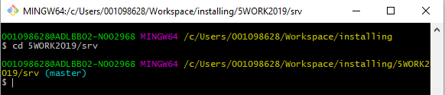

Figure 4: Navigating into the srv folder

1. Execute the installer npm install

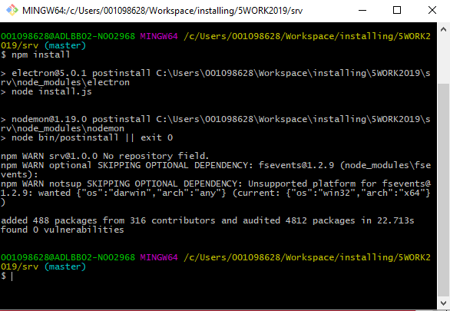

Figure 5: Executing the installer for SRV Management System

1. Start your program.

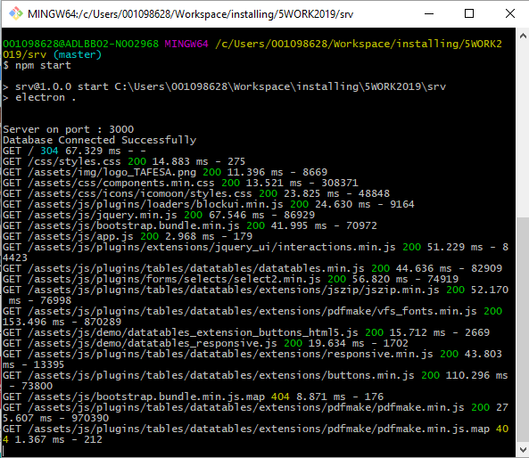

Figure 6: Starting your program

1. Allow access if requested.

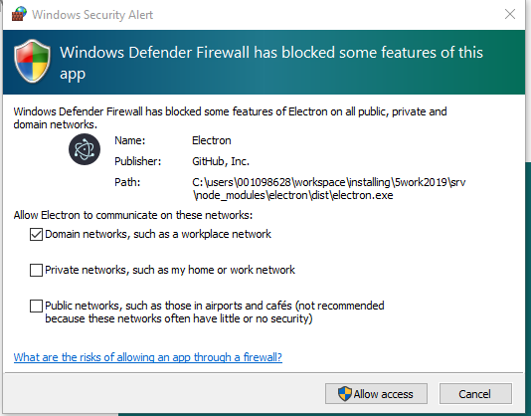

Figure 7: Allow access

How to use SRV Management System

How to login as a Student

Login as a Student. – User: student, Password: student

|  |
| --- |
|  |

Figure 8: Main window for SRV Management System

## How to view the dashboard

Once SRV Management System has finished checking your credentials it will send you to your dashboard.

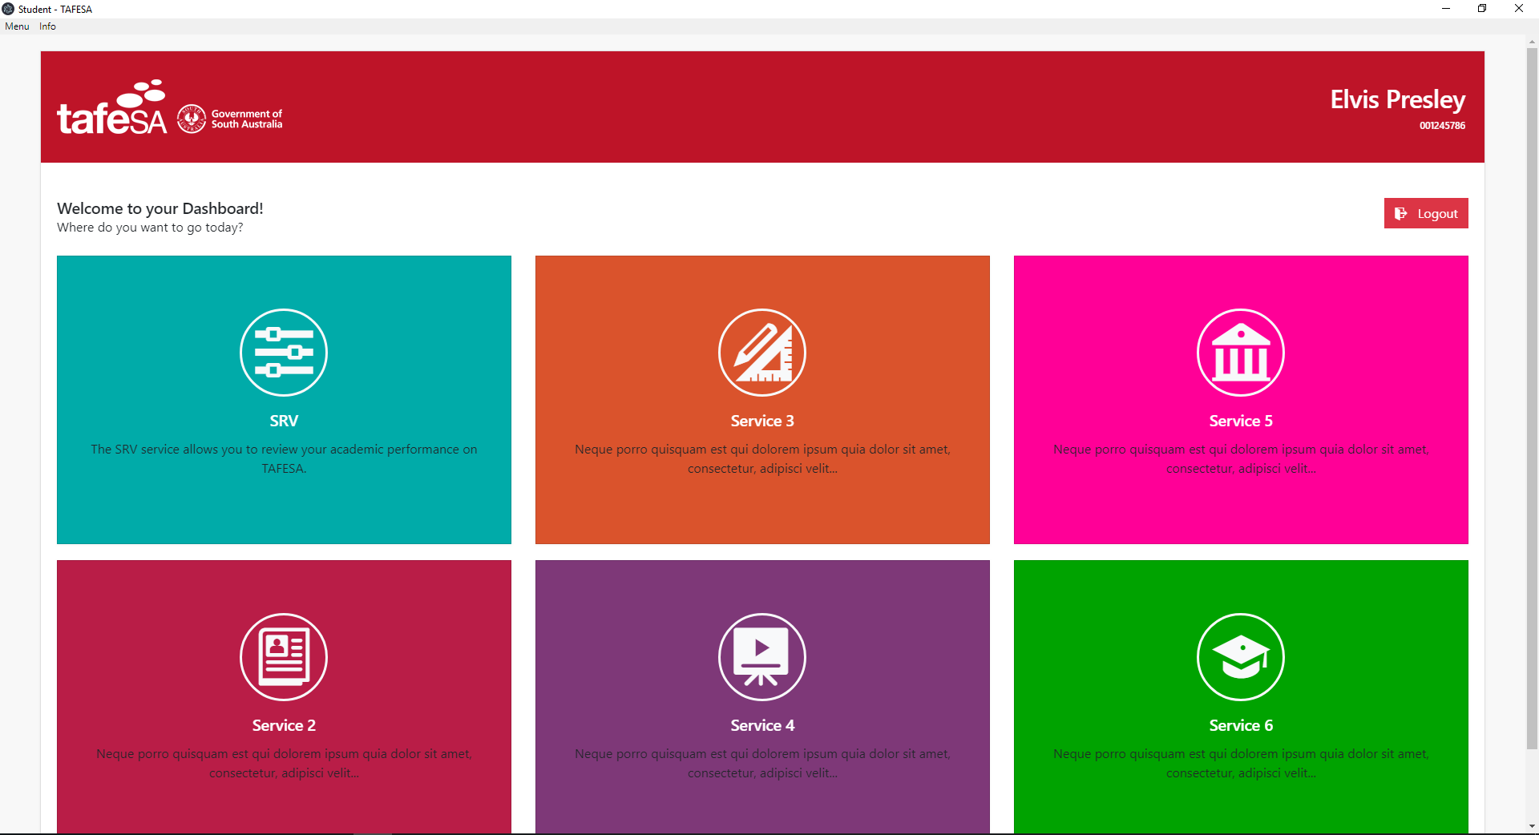

Figure 9: Student Dashboard

## How to access SRV

The first icon will send you to the student SRV

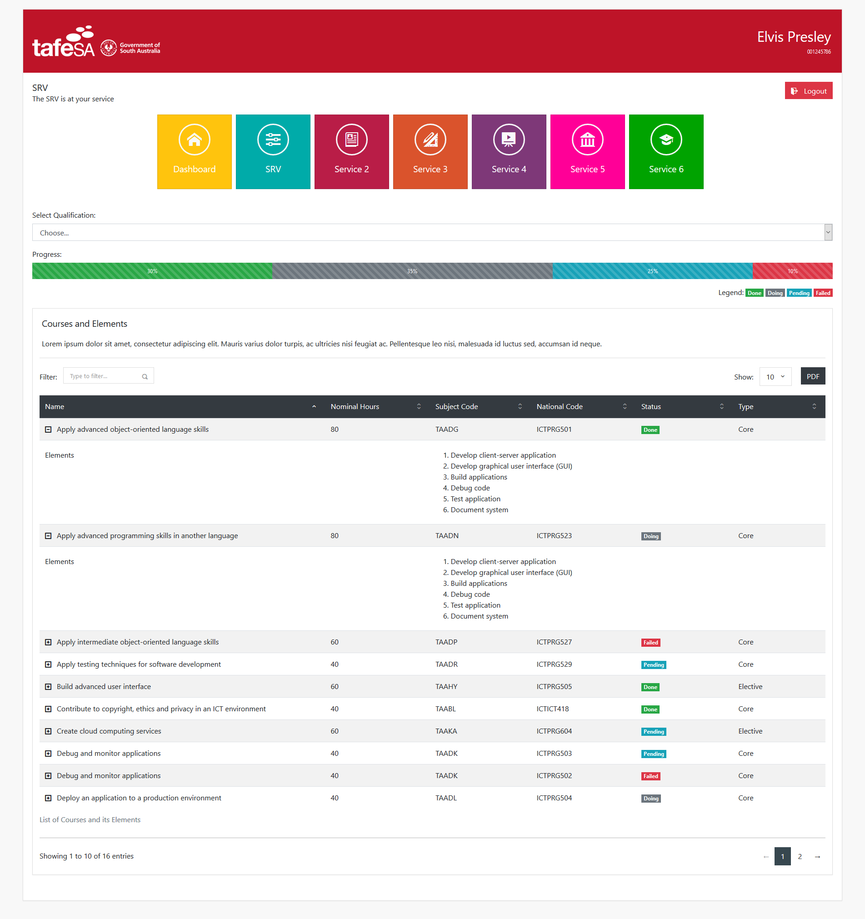

Figure 8: Student SRV

## How to filter by courses

Find the filter input textbox and just type your keyword.

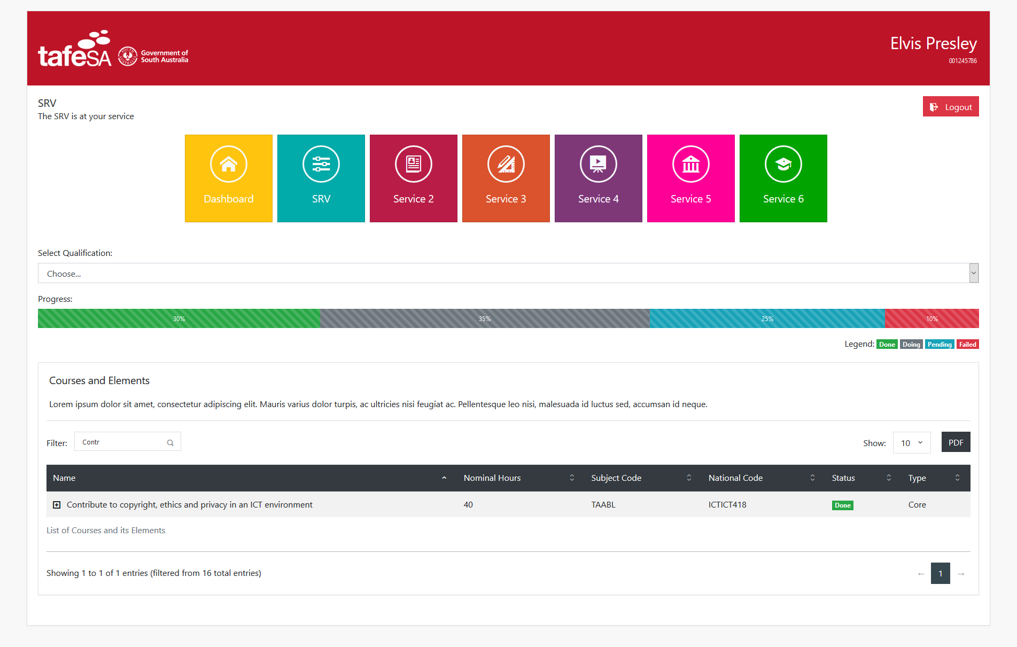

Figure 11: Filtering courses

## How to export the table to a PDF file

Just click the PDF button

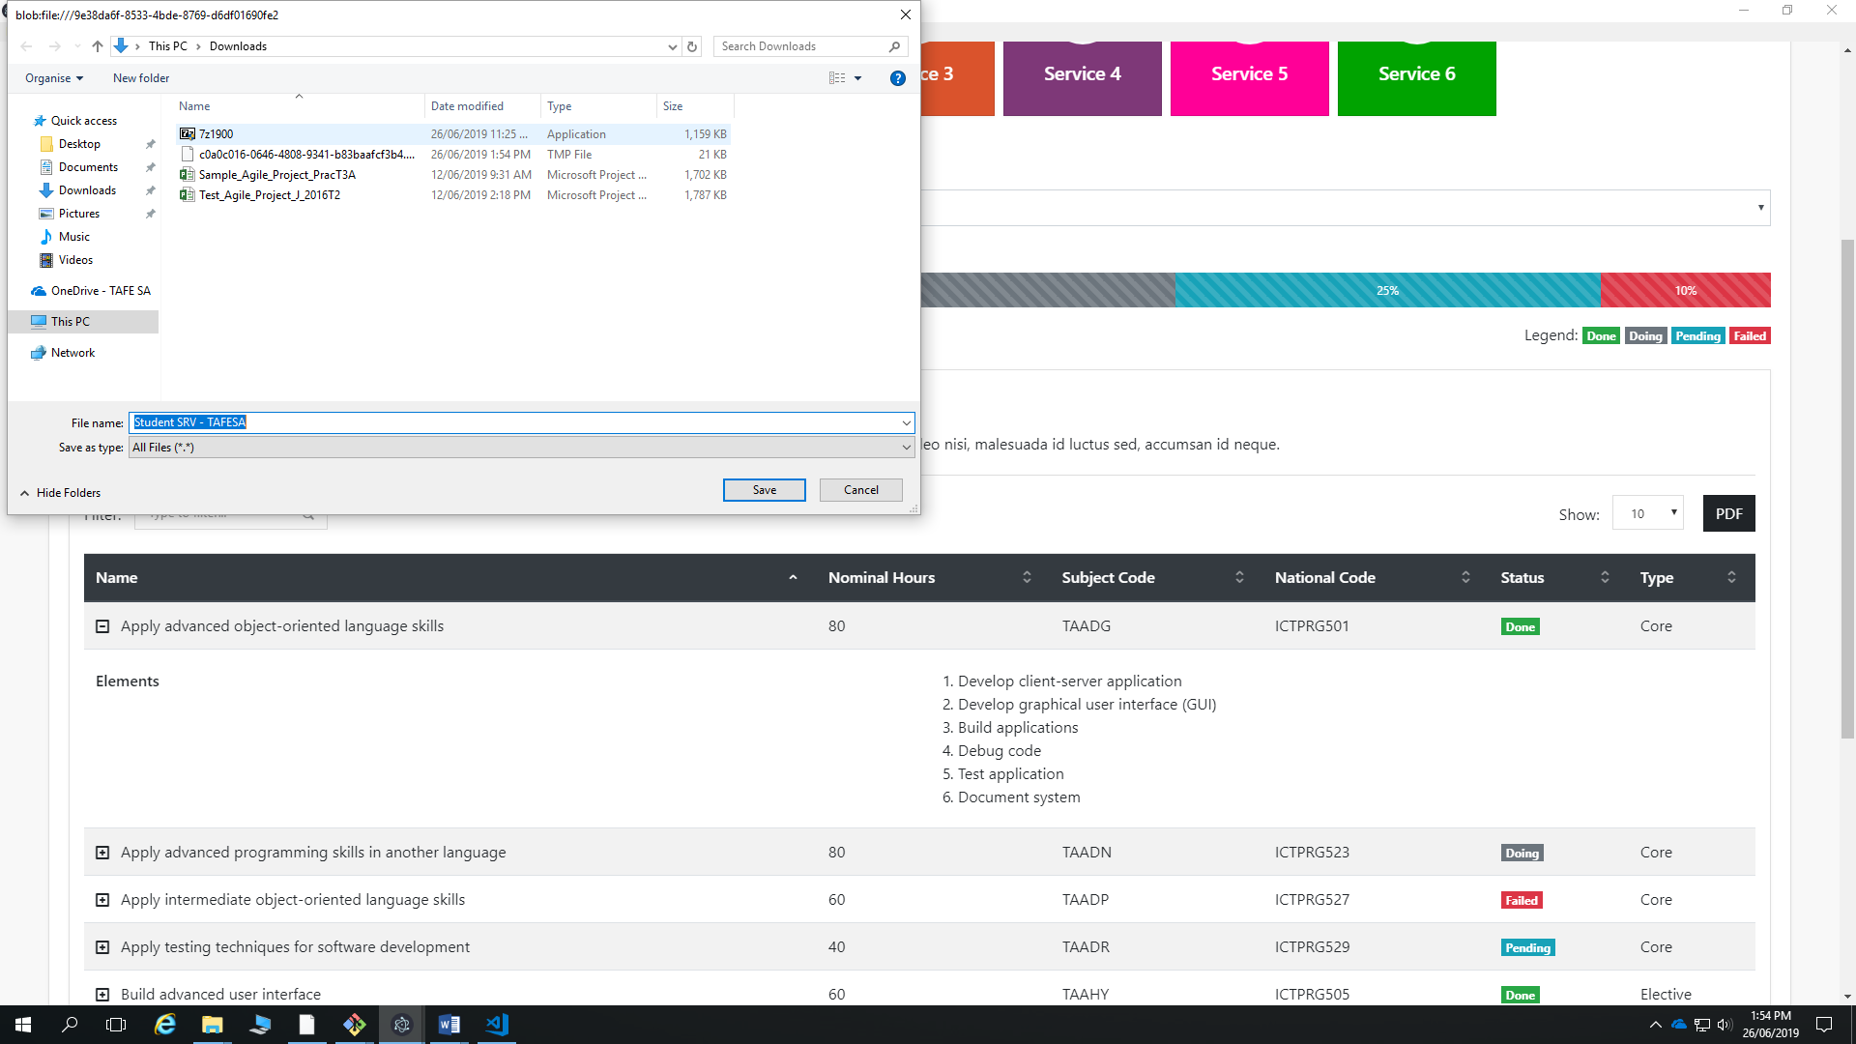

Figure 12: Exporting the PDF file

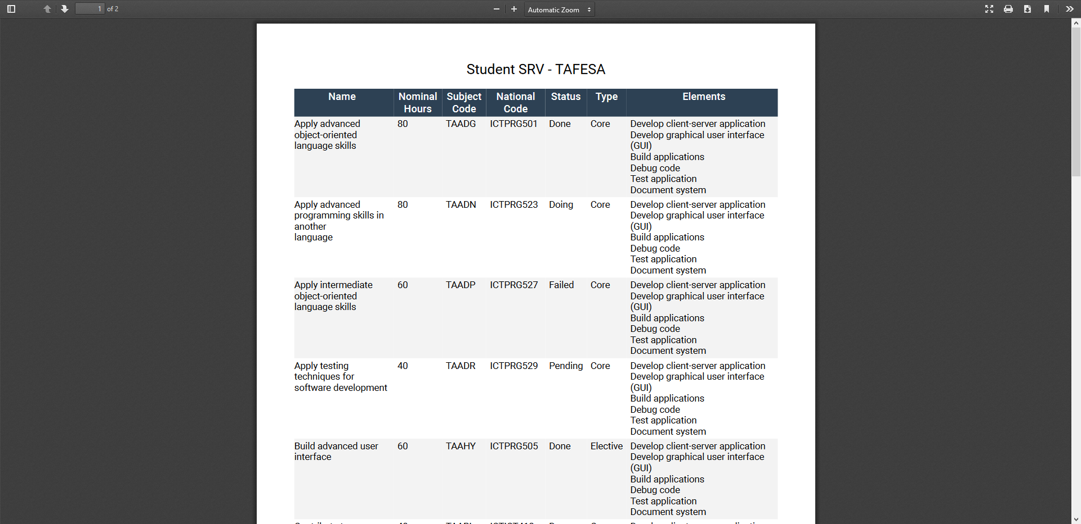

Figure 13: PDF file

How to login as a Lecturer

Login as a Lecturer. – User: lecturer, Password: lecturer

|  |
| --- |
|  |

Figure 14: Main window for SRV Management System

## How to view the dashboard

Once SRV Management System has finished checking your credentials it will send you to your dashboard.

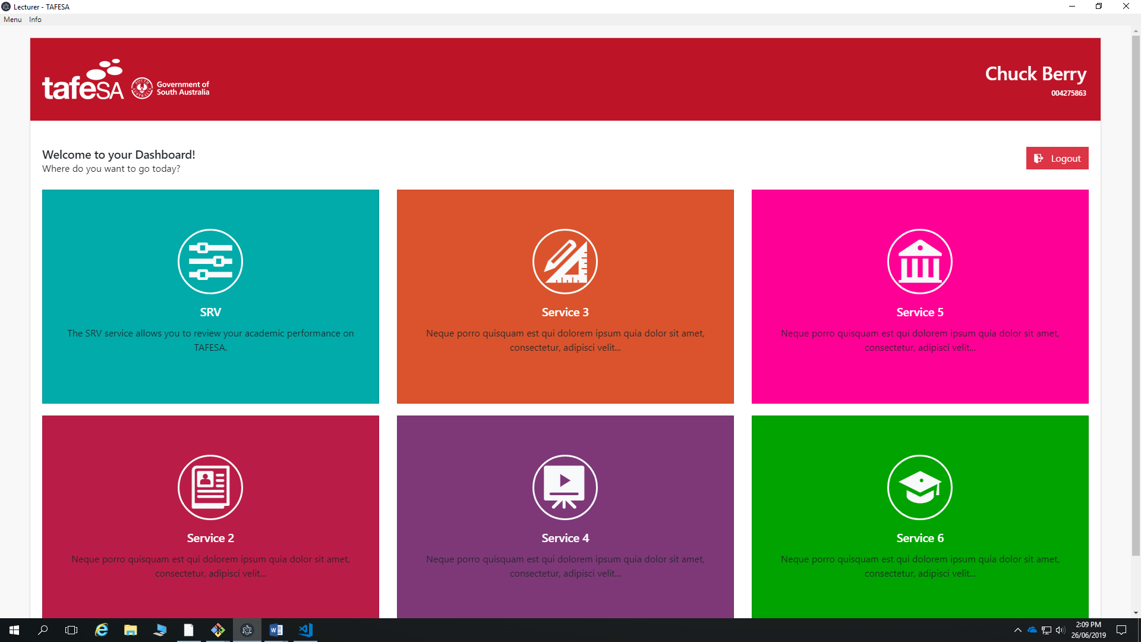

Figure 15: Lecturer Dashboard

## How to access SRV

The first icon will send you to the Lecturer SRV

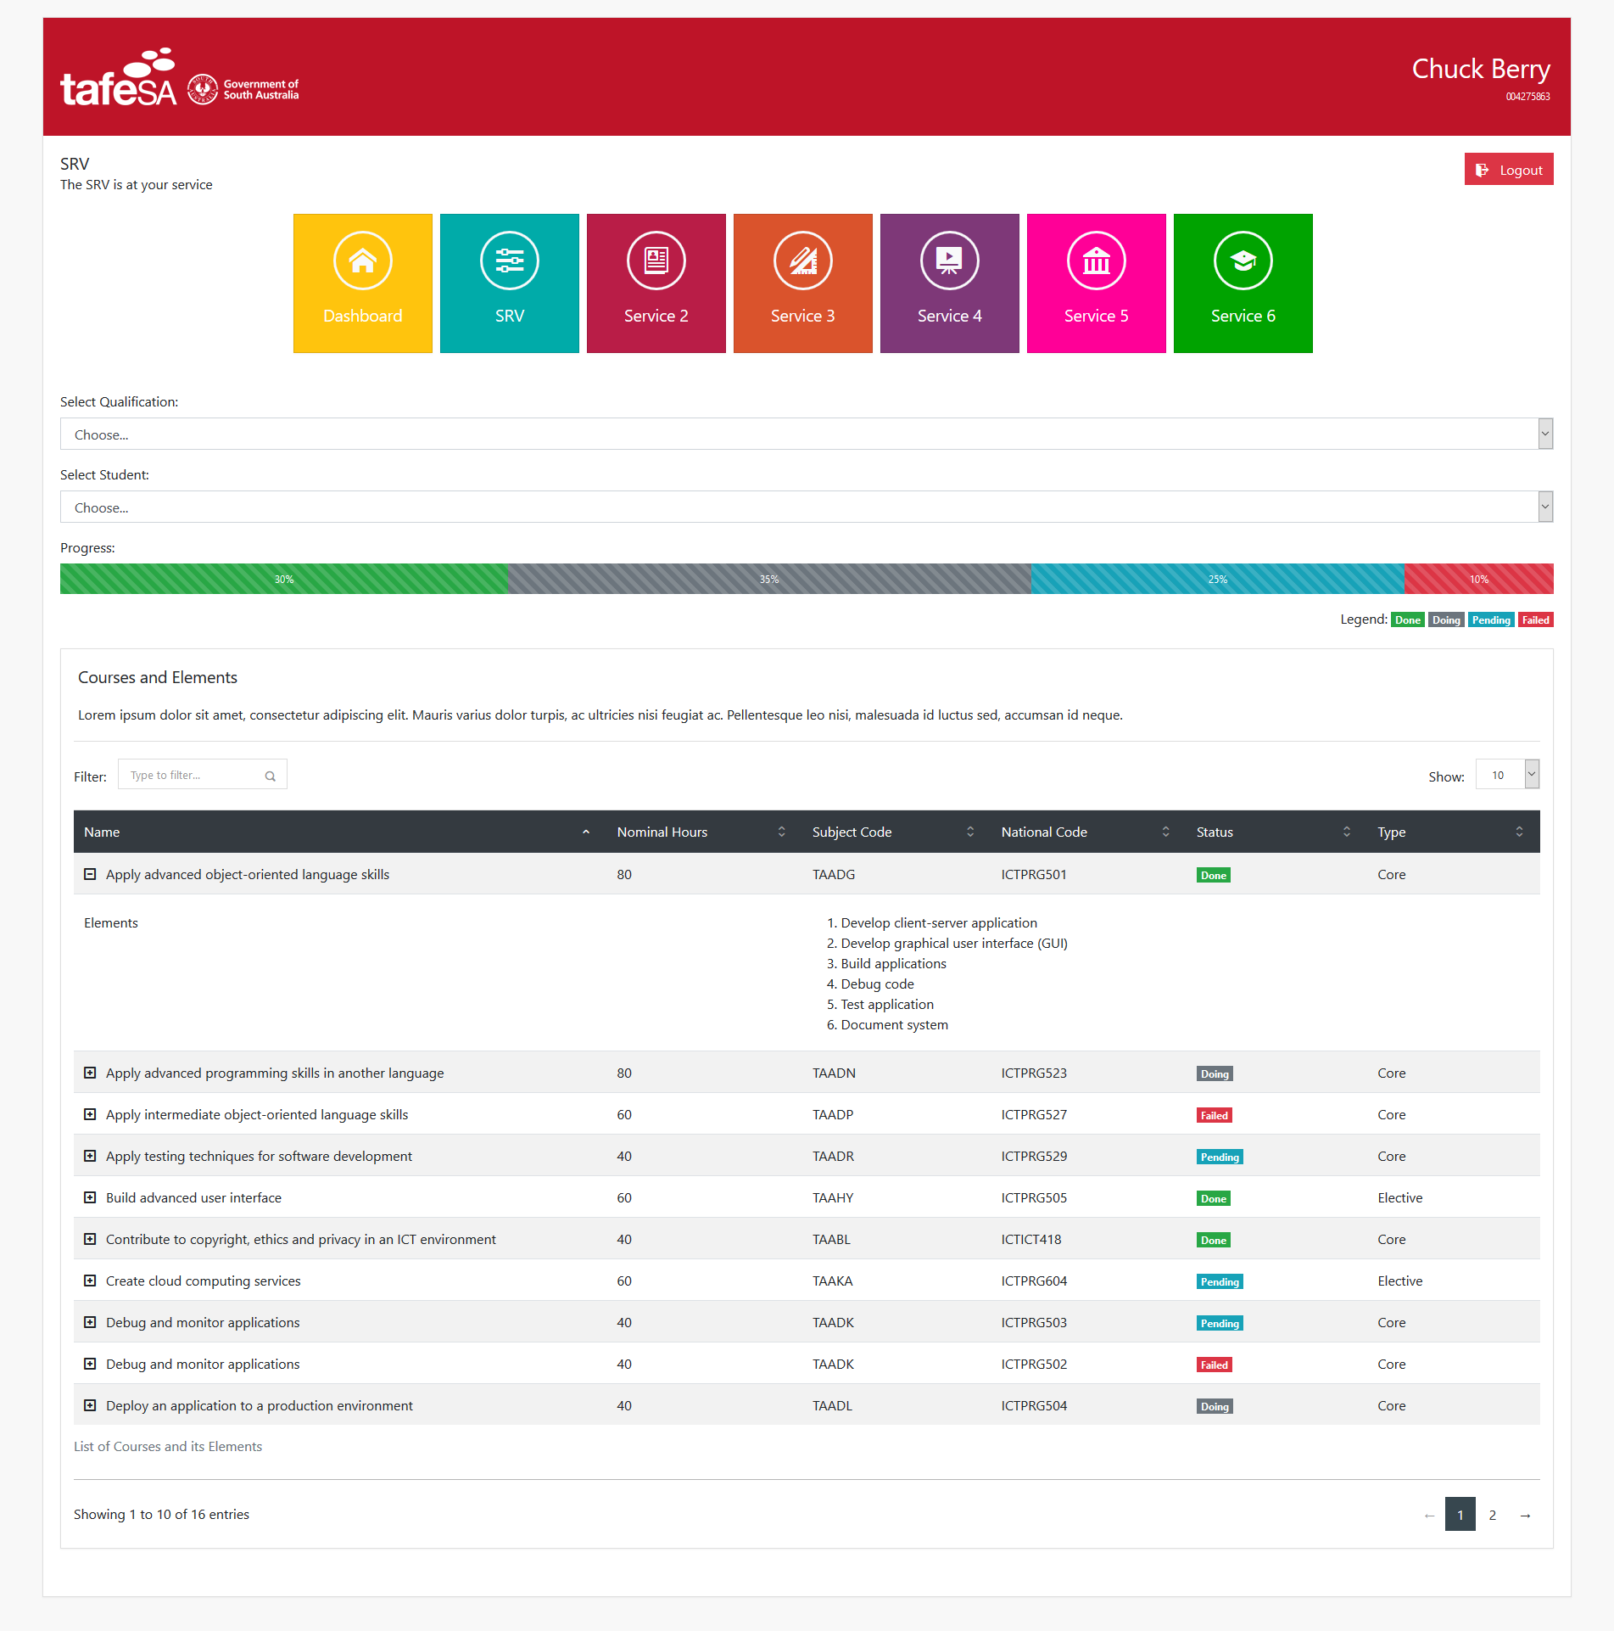

Figure 16: Lecturer SRV

## How to filter by courses

Find the filter input textbox and just type your keyword.

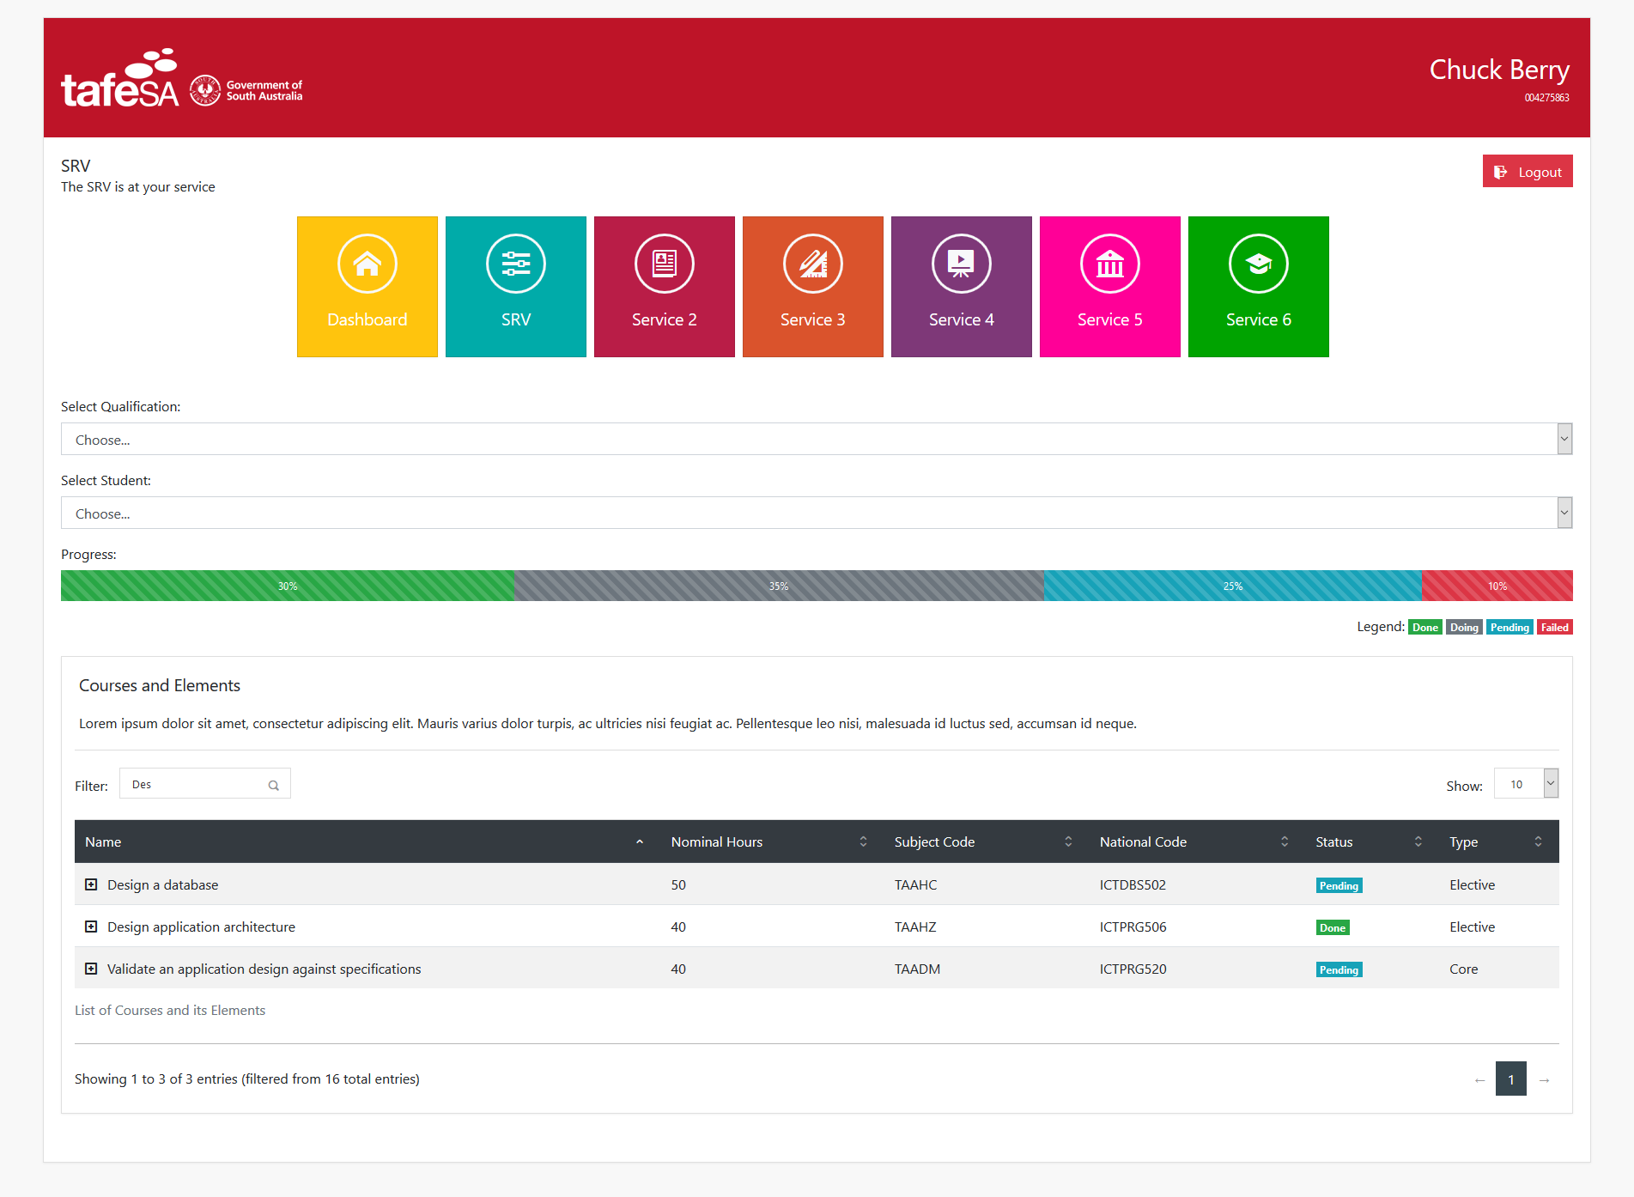

Figure 17: Filtering courses

How to login as an Administrator

Login as an Administrator. – User: admin, Password: admin

|  |
| --- |
|  |

Figure 18: Main window for SRV Management System

## How to view the dashboard

Once SRV Management System has finished checking your credentials it will send you to your maintainers for Admins, Lecturers and Students

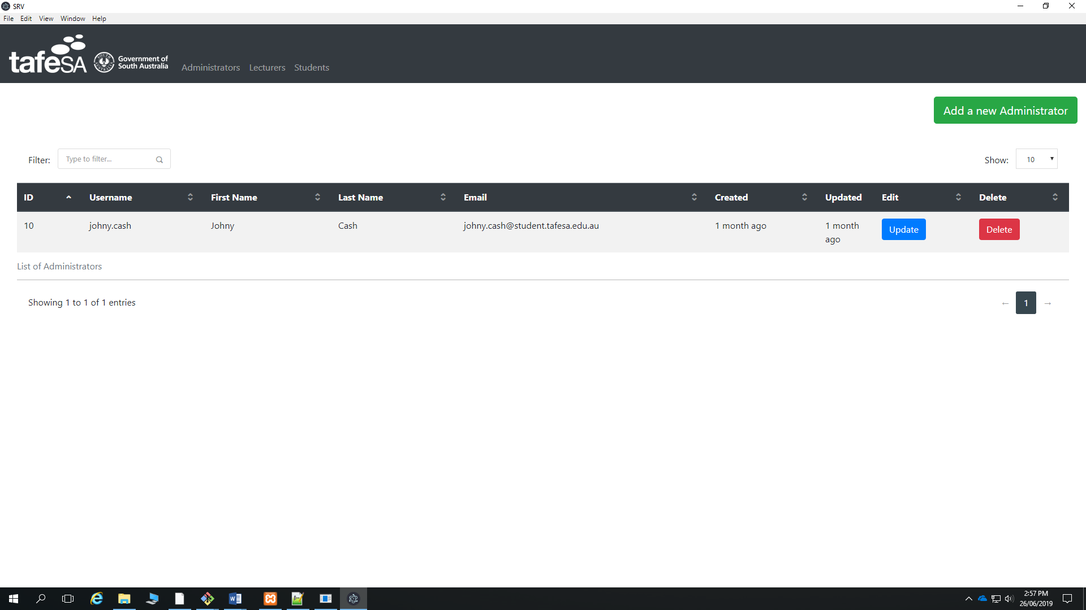

Figure 19: Admin CRUD

## How to add an Administrator

Click the button “Add a new Administrator”

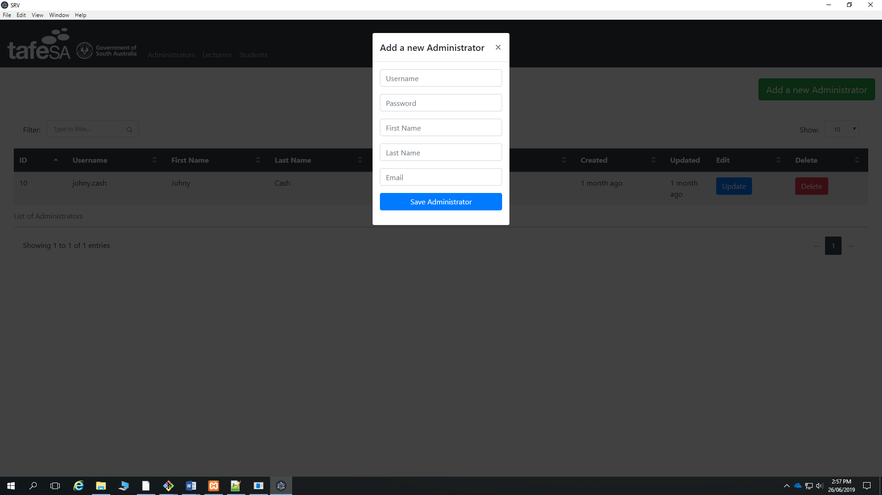

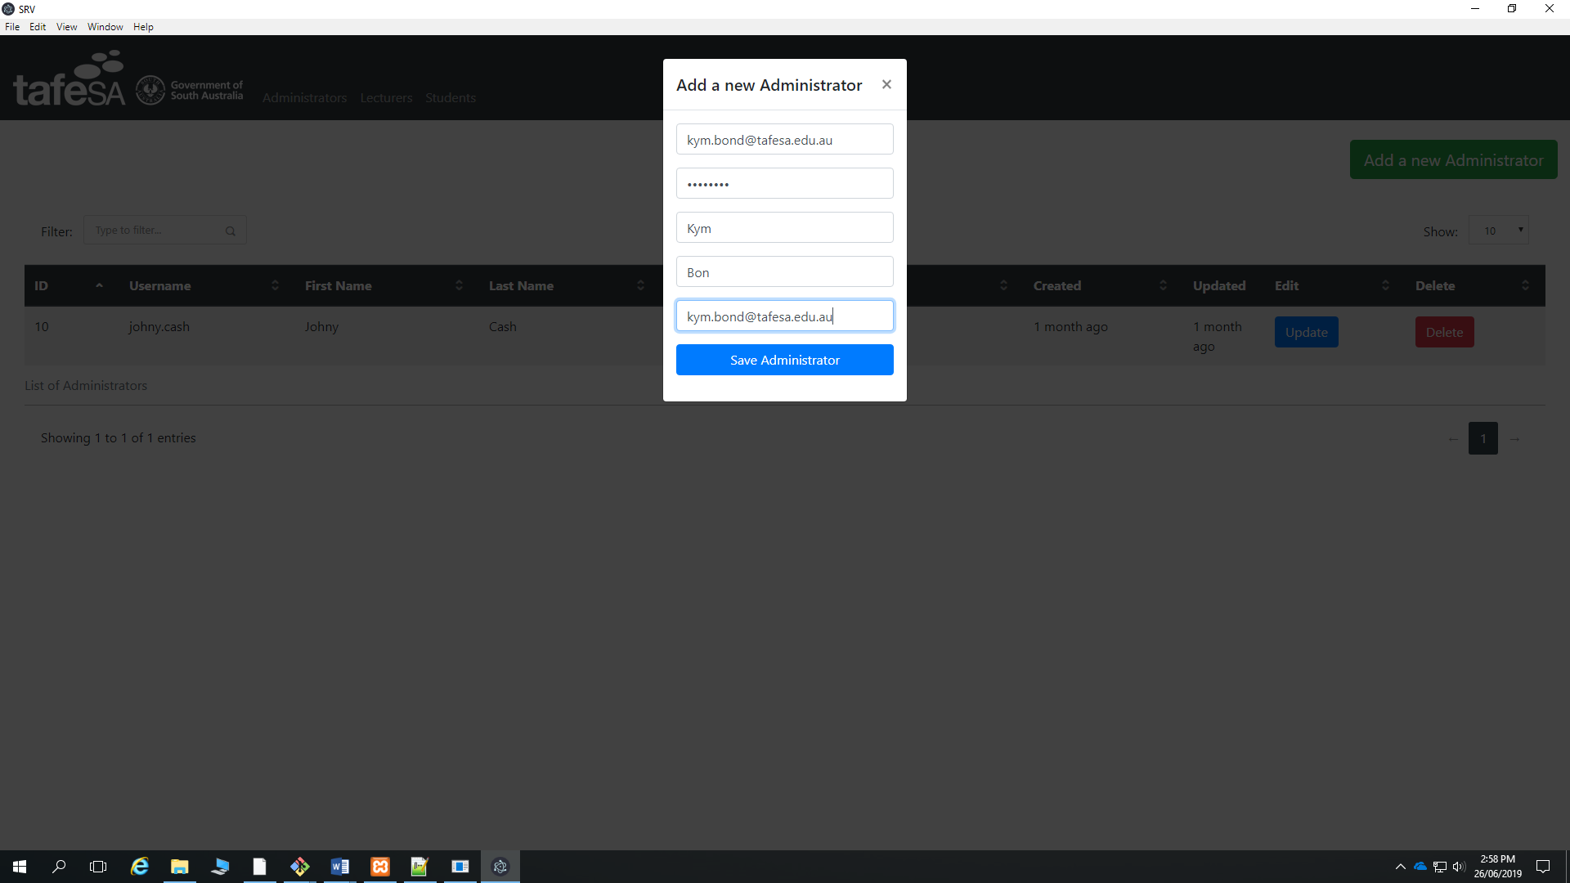

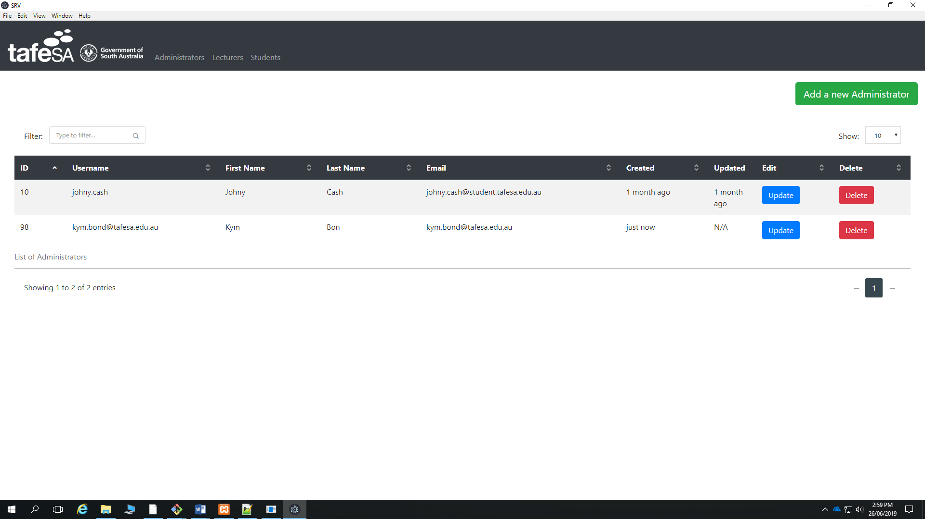

Figure 21: Adding an administrator for SRV

## How to Update an Administrator

Look for the Administrator you want to edit and click the Update button.

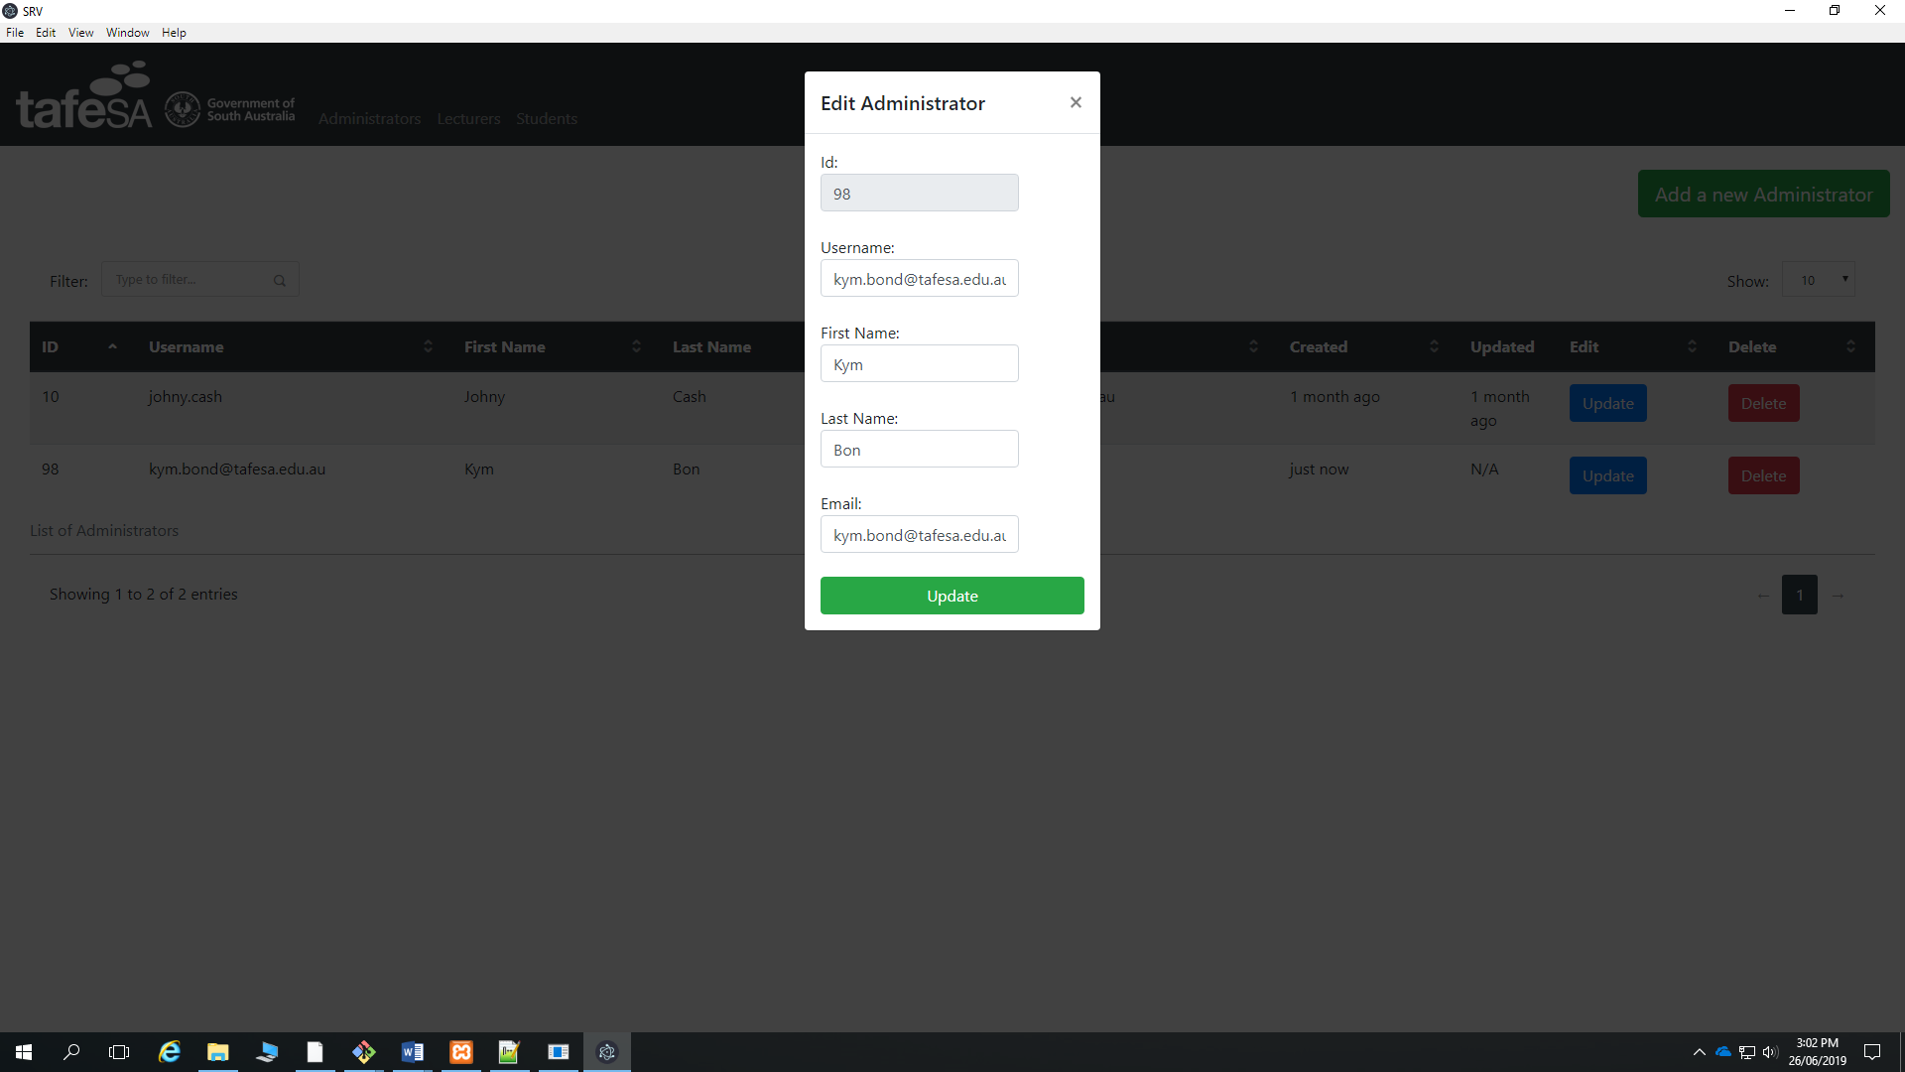

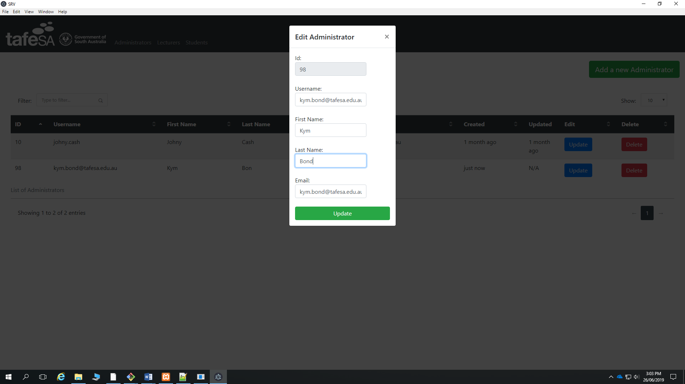

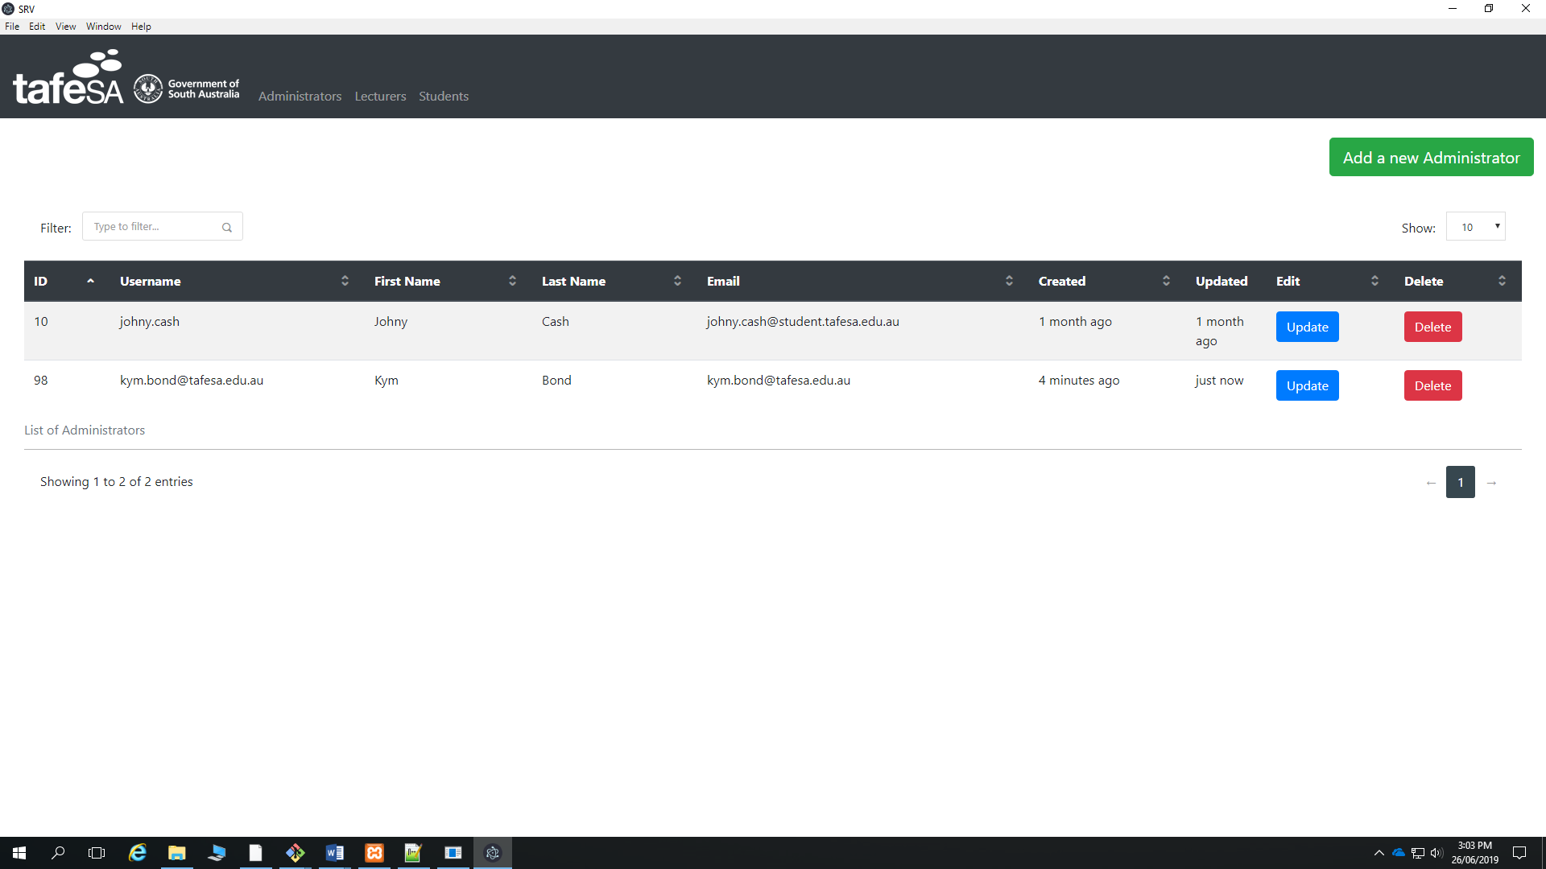

Figure 22: Editing Administrators

## How to delete an Administrator

Just click the Delete button

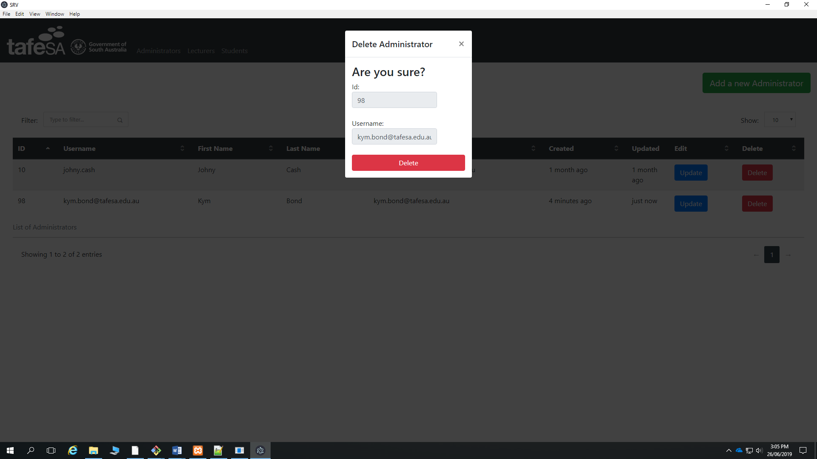

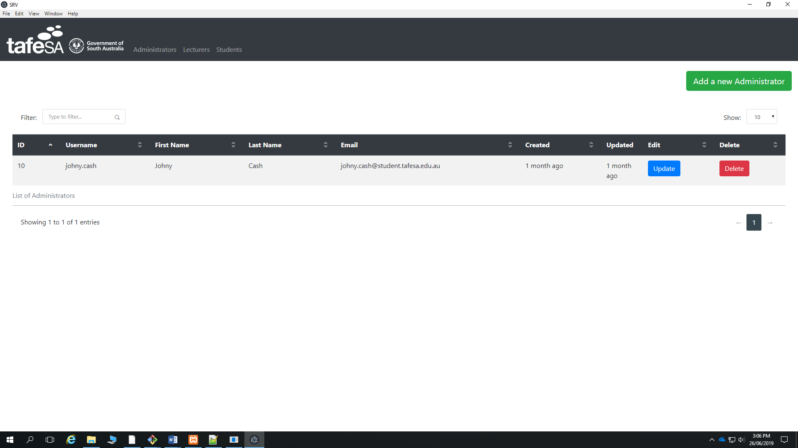

Figure 23: Deleting an Administrator

## How to add a Lecturer

Click the button “Add a new Lecturer”

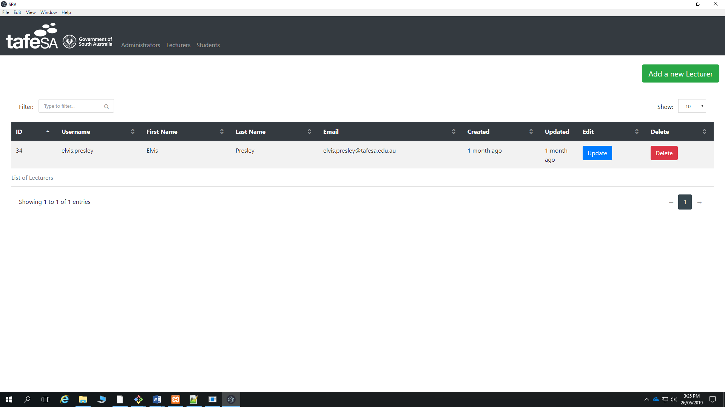

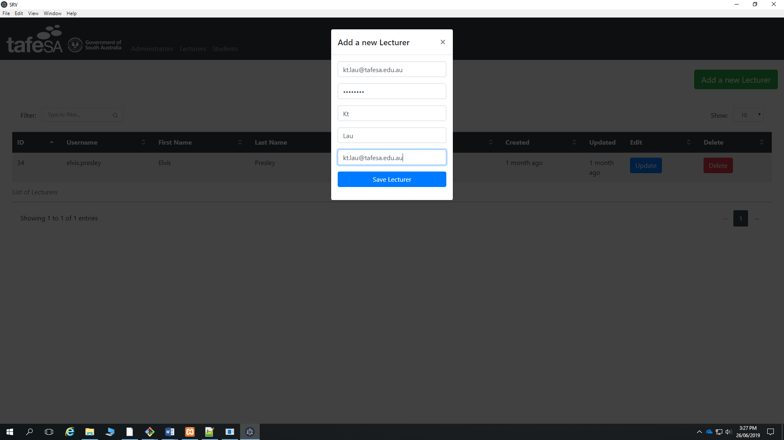

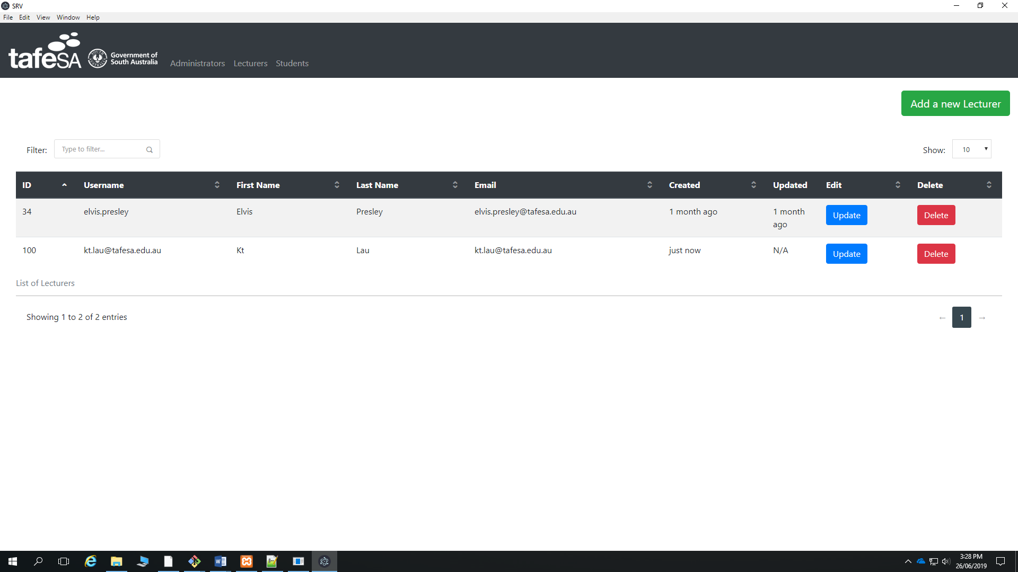

Figure 24: Adding a Lecturer for SRV

## How to Update a Lecturer

Look for the Lecturer you want to edit and click the Update button.

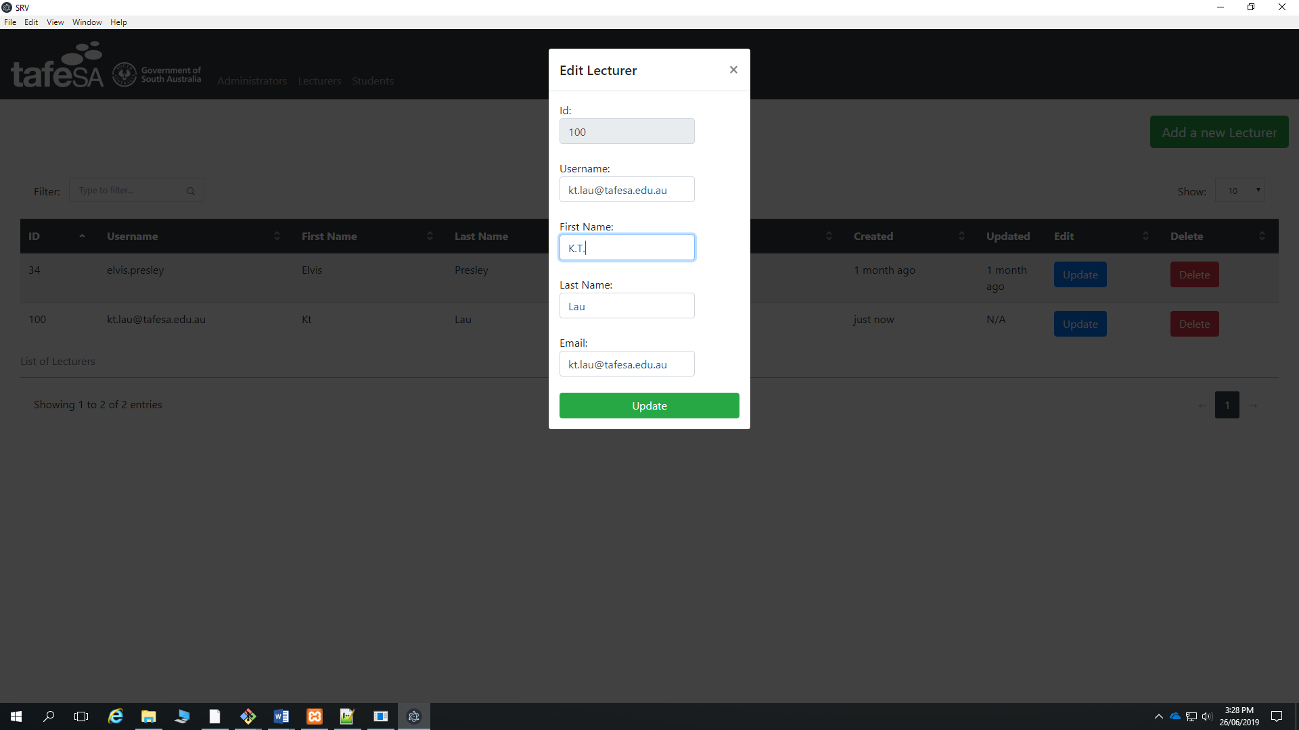

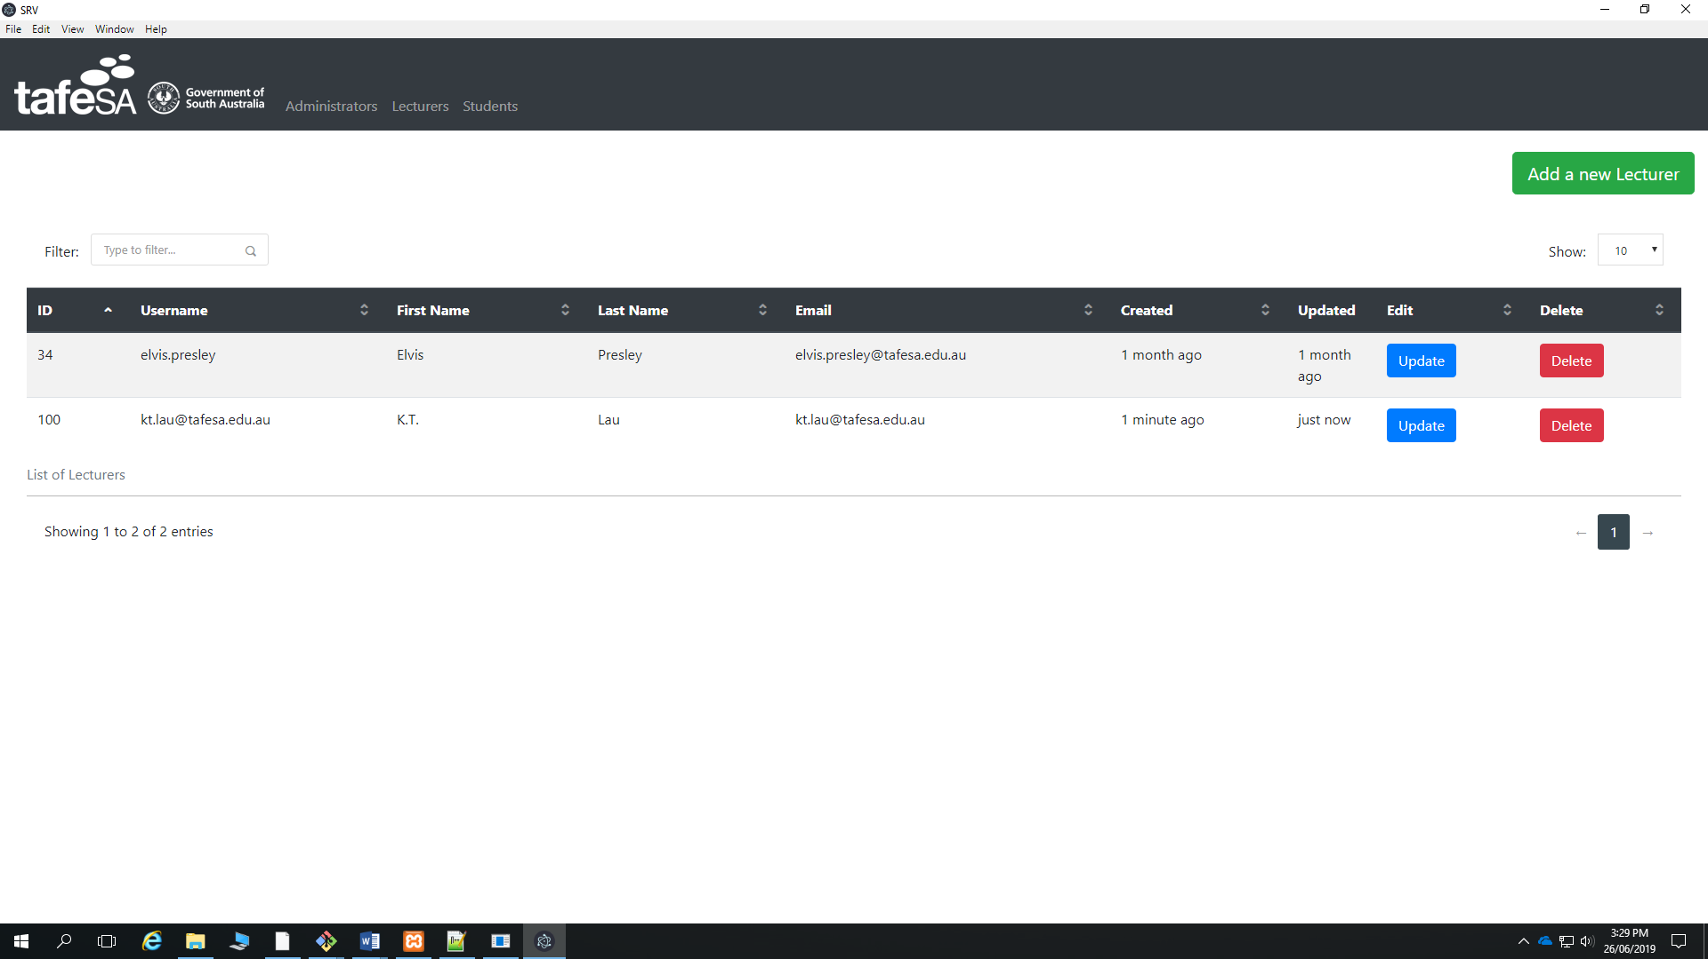

Figure 25: Editing Lecturers

## How to delete a Lecturer

Just click the delete button

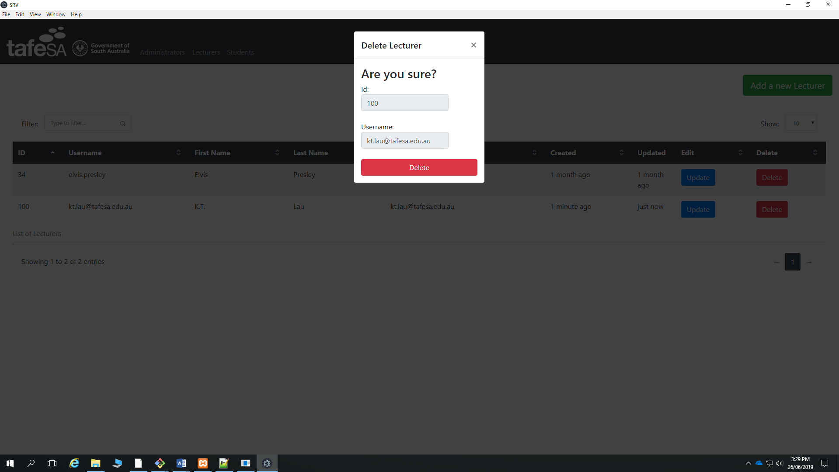

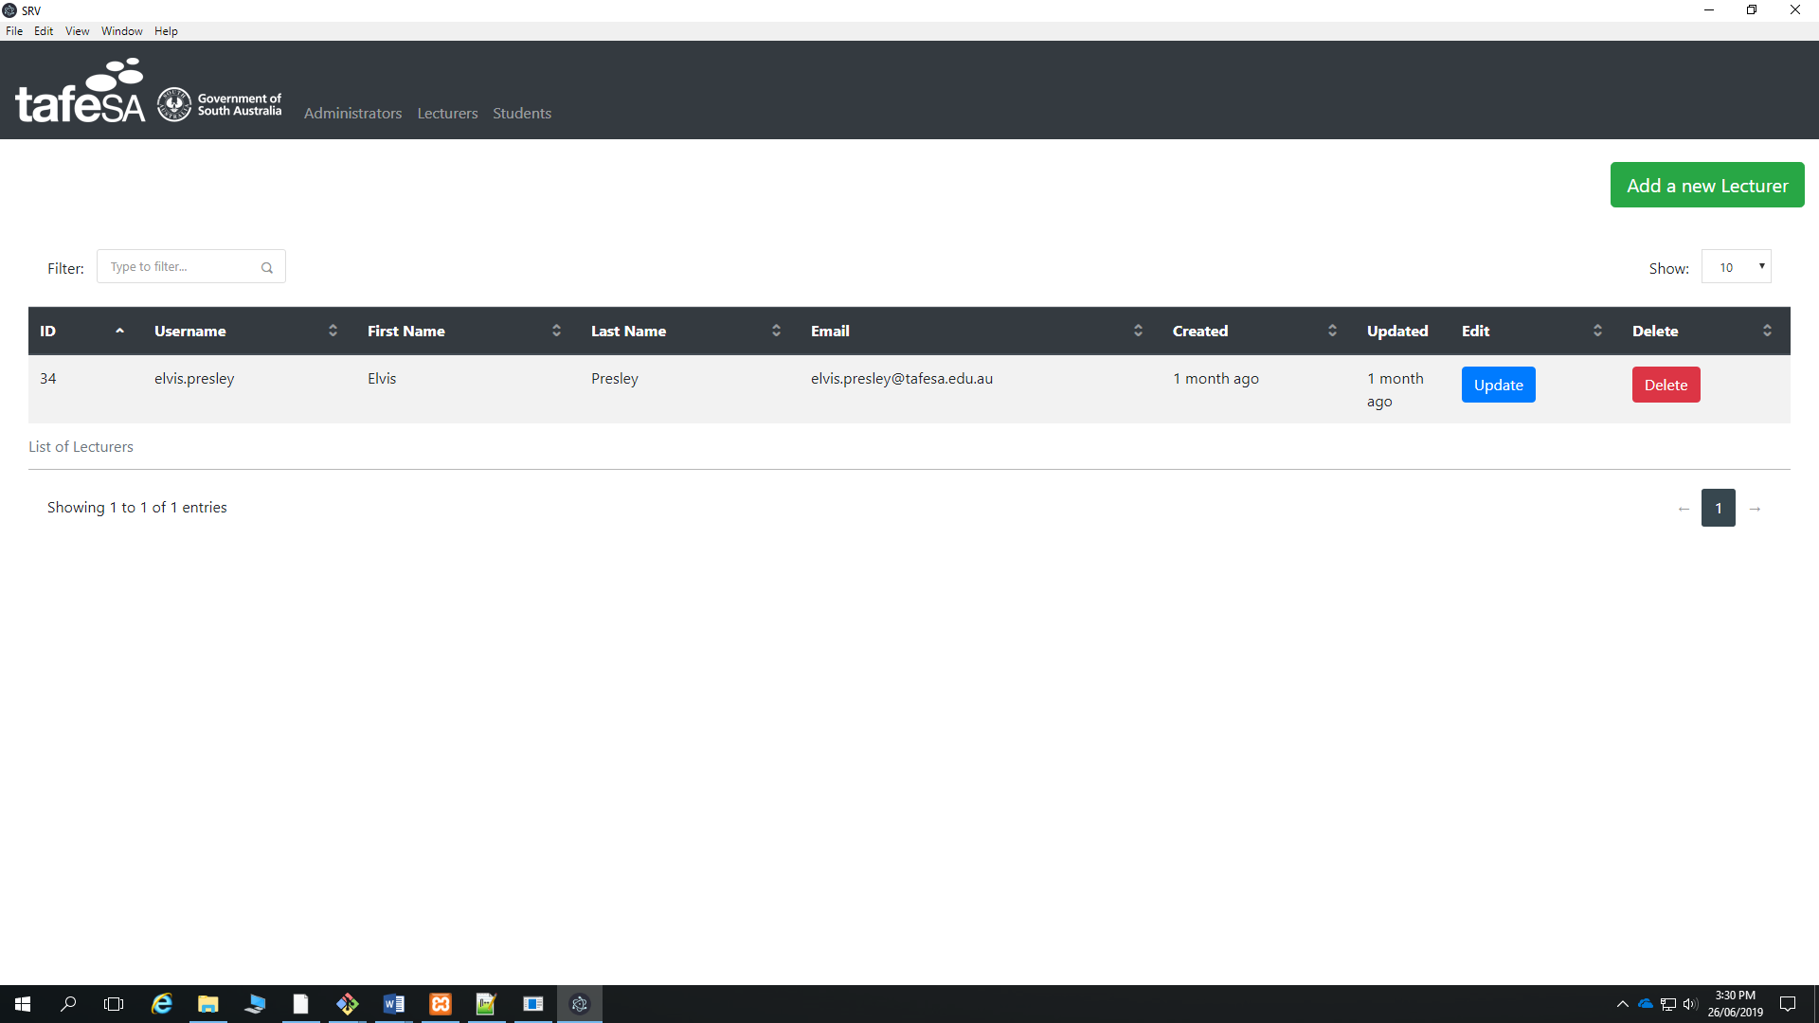

Figure 26: Deleting a Lecturer

## How to add a Student

Click the button “Add a new Student”

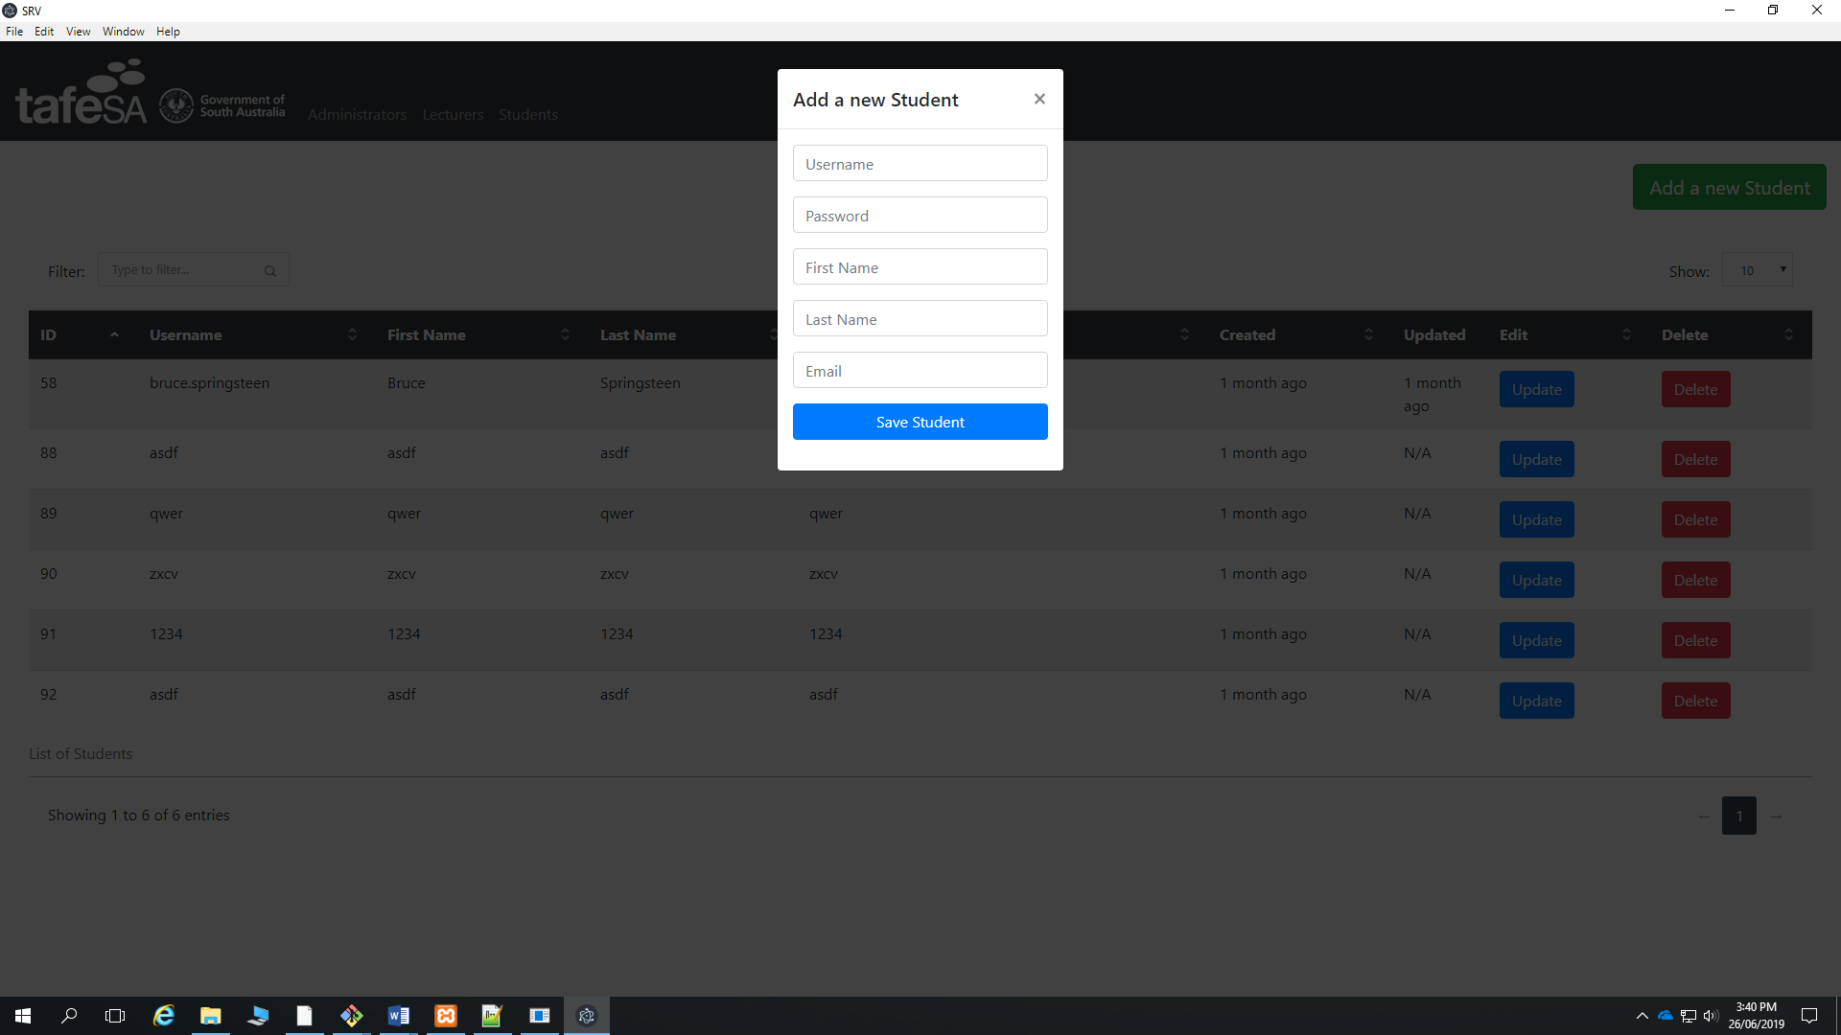

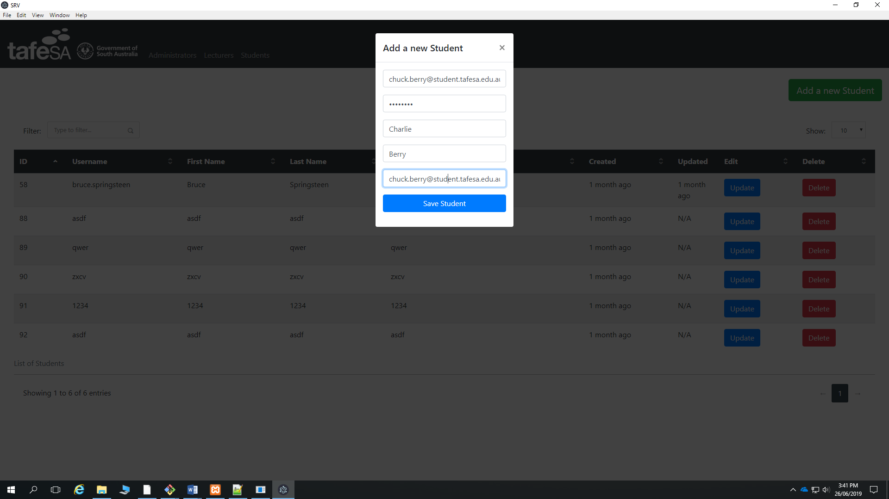

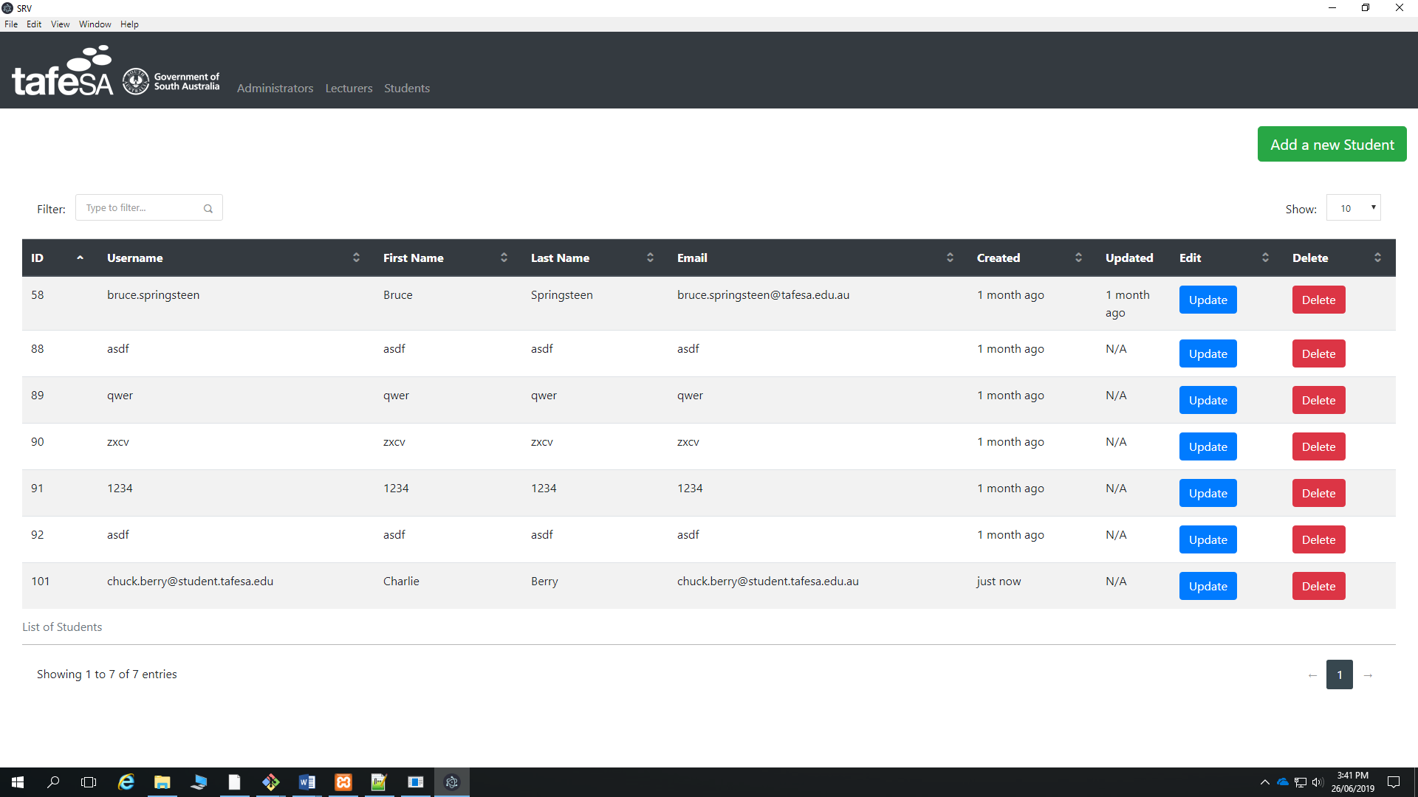

Figure 27: Adding a Student for SRV

## How to Update a Student

Look for the Student you want to edit and click the Update button.

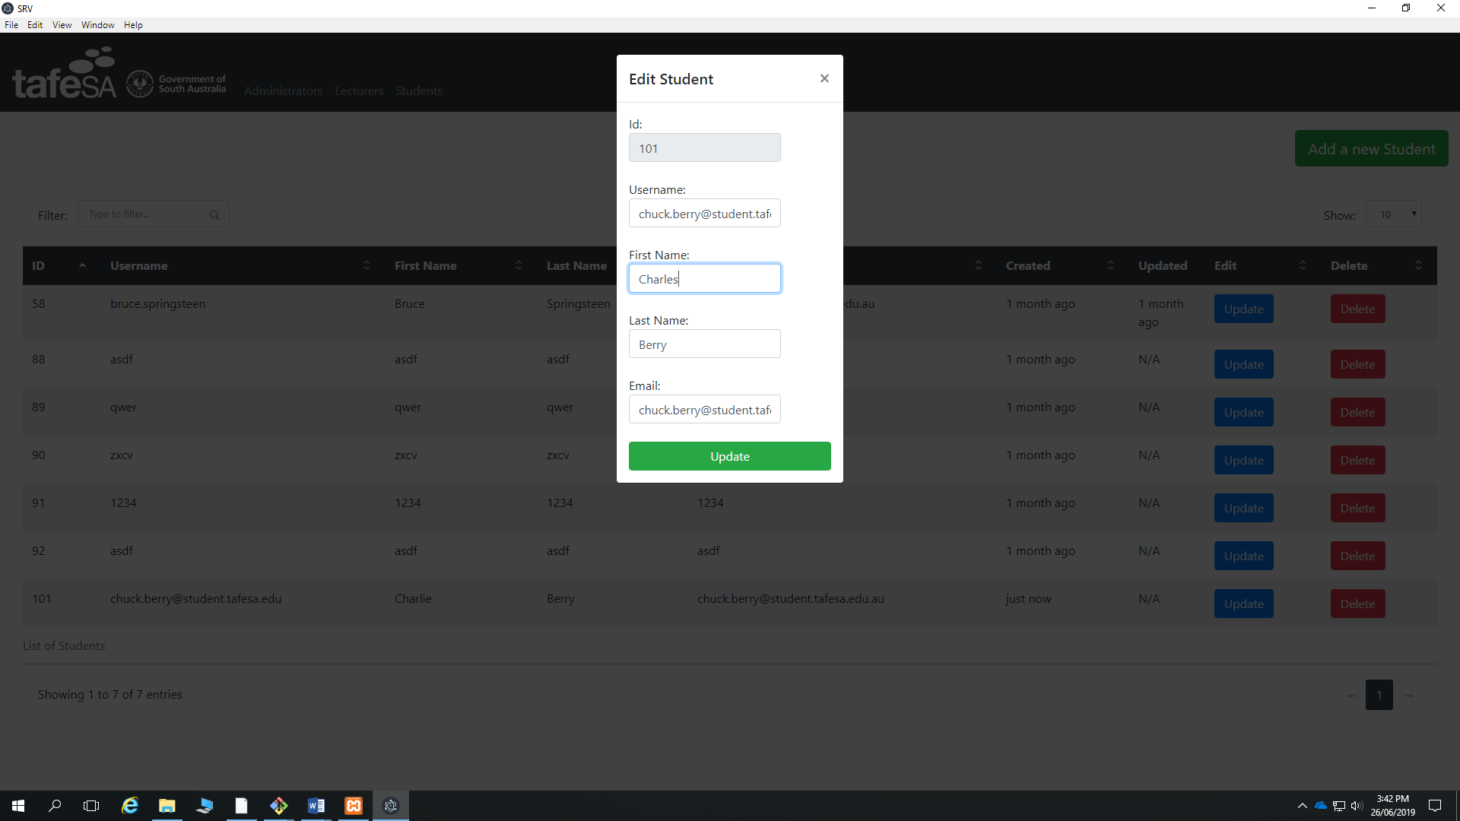

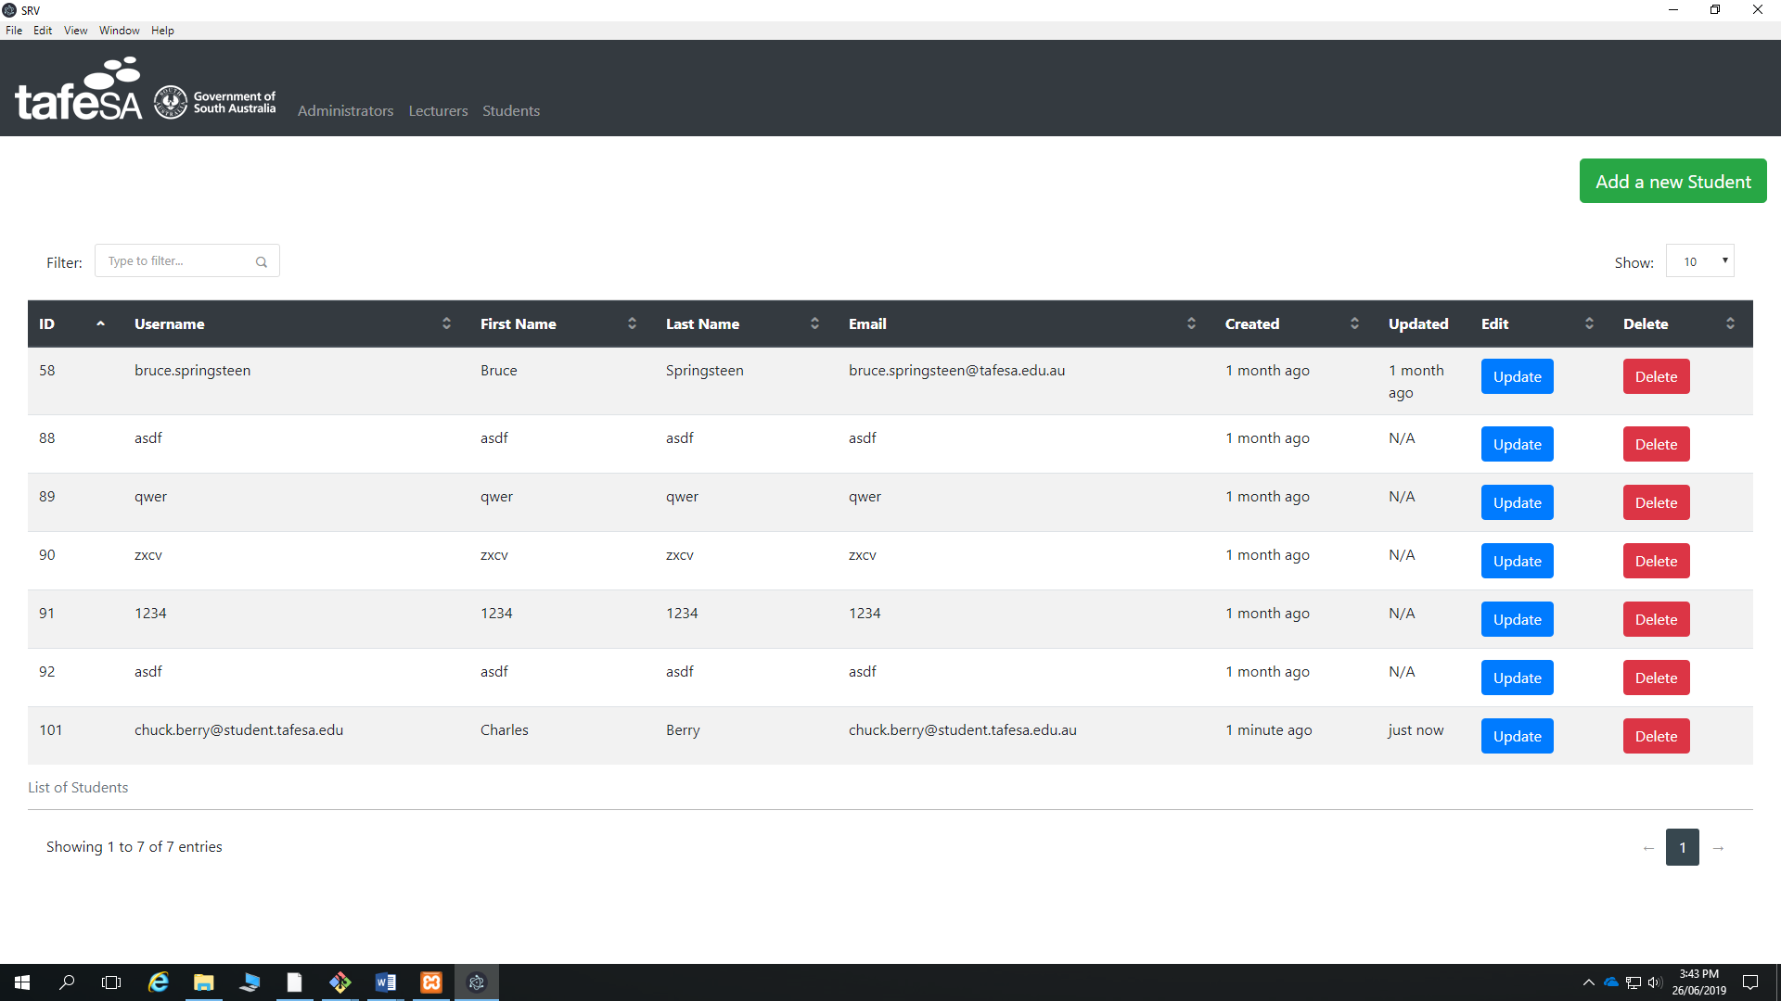

Figure 28: Editing Students

## How to delete a Student

Just click the delete button

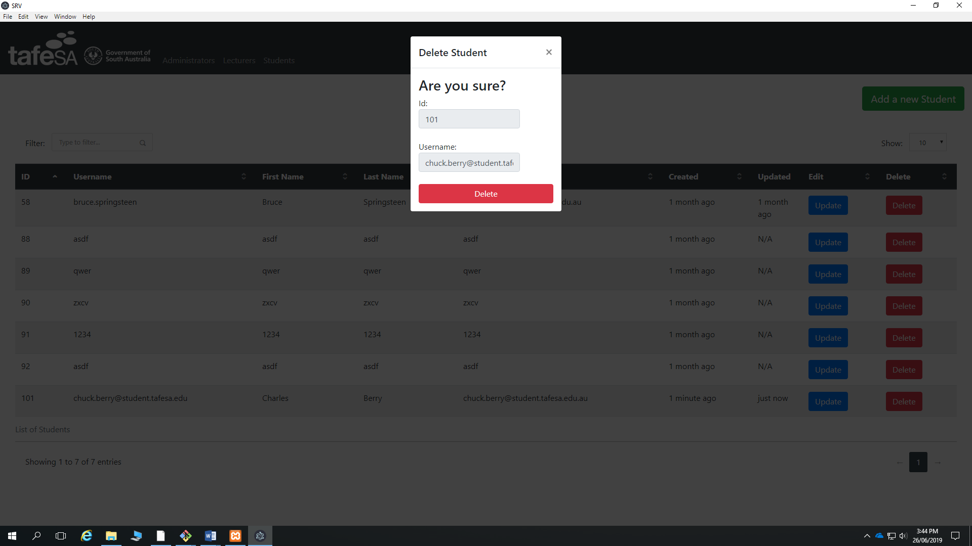

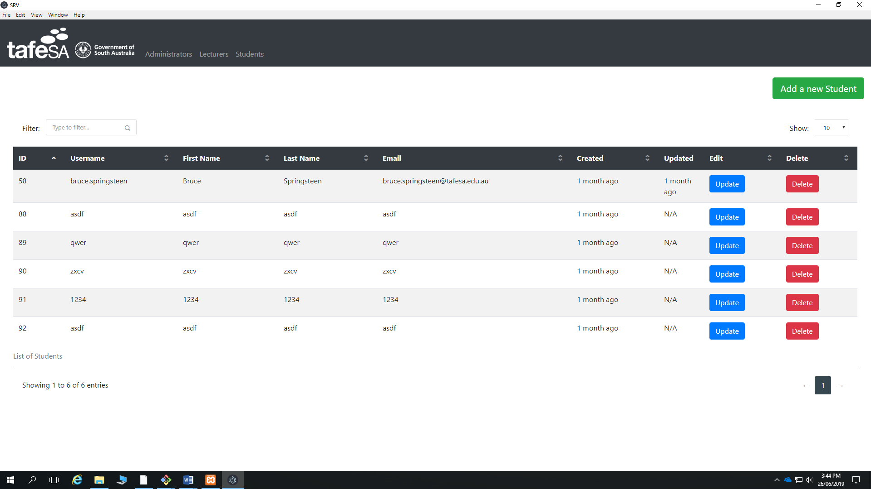

Figure 29: Deleting a Student

Troubleshooting & FAQ

Common problems

**Q – Why won’t SRV Management System install/run on my computer?**

Please make sure you are using SRV Management System on a computer with an internet connection. Since is cross-platform it will run on Windows, Linux and Mac.

**Q – SRV Management System isn’t adding the Administrators, Lecturers or Students?**

SRV Management System requires an internet connection, please make sure your pc is connected.

Contact details

For further help on using SRV Management System just click on info and then in Source Code

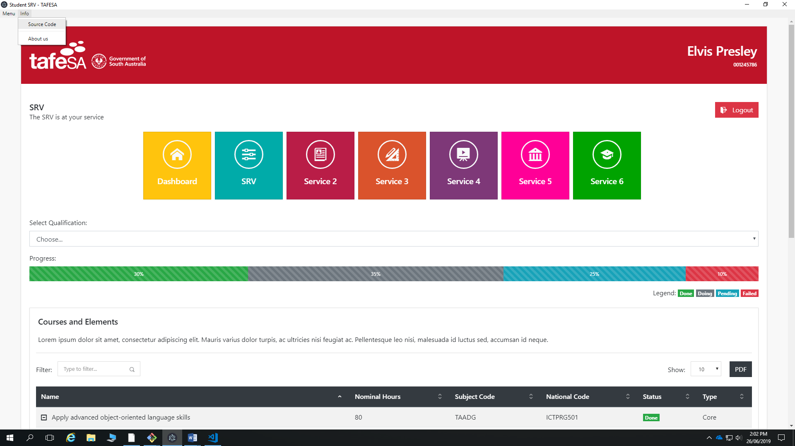

Figure 30: Source code

About us

For information regarding the developers, click Info and the About Us

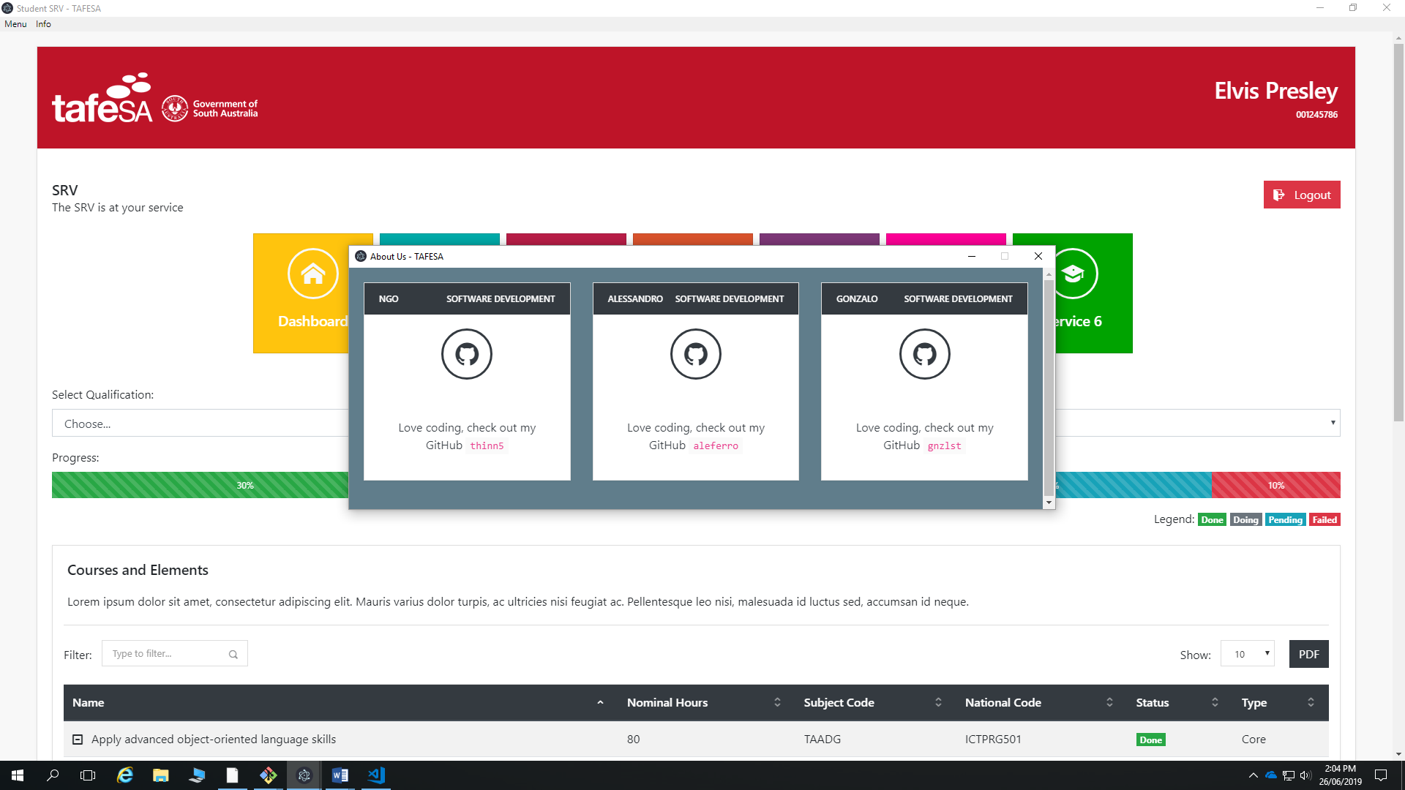

Figure 31: Source code

Acknowledgements

SRV Management System is the property of Team NAG

This document is written in accordance to the ISO guidelines for software related user documentation as well as the ITWorks Style and Standards Guide for User Documentation. All material in this document is property of ITWorks.

This document is for internal use only and is not to be distributed to the public unless instructed otherwise.

Notes

Version 00.0011 – Amended font colour and pagination issue

Version 00.0010 – End user documentation drafted and sent for review

Version 00.0001 – Outline established for end user documentation